Bangladesh Medical Association (BMA)
List of Life Member-441
65. BMA Sylhet Branch

Sl No | Voter No | Voter Details
1 | Voter No  LM-6500001  No Image | DR. MOHAMMAD AFZAL  F/Name:  M/Name:  BM & DC Reg. No:  NID:  Cell:  Address: Nayerpool Sylhet  Blood Group:
2 | Voter No  LM-6500002  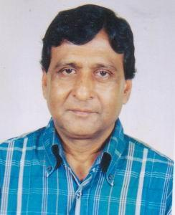 | DR. MD. ABDUL HYE  F/Name:  M/Name:  BM & DC Reg. No:  NID:  Cell:  Address: 78, Housing Estate R/S Sylhet  Blood Group:
3 | Voter No  LM-6500003  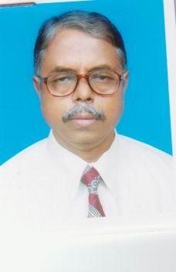 | DR. MAINUL ISLAM  F/Name:  M/Name:  BM & DC Reg. No:  NID:  Cell:  Address: Fahim Villa 10, Sagar Digir Par Sylhet  Blood Group:
4 | Voter No  LM-6500004  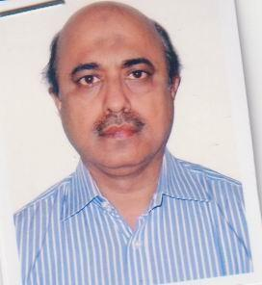 | DR. WAZIR AHMED CHOWDHURY  F/Name:  M/Name:  BM & DC Reg. No:  NID:  Cell:  Address: Associate Professor ENT Outdoor Medical Officer Sylhet  Blood Group:
5 | Voter No  LM-6500005  No Image | DR. NASIMA BEGUM  F/Name:  M/Name:  BM & DC Reg. No:  NID:  Cell:  Address:  Blood Group:  TRANSFERED to BMA Dhaka City  LM-1405543
6 | Voter No  LM-6500006  No Image | DR. ANWARA KHATUN  F/Name:  M/Name:  BM & DC Reg. No:  NID:  Cell:  Address: Asstt. Prof. OBS & Gynae Osmani Medical College Sylhet  Blood Group:
7 | Voter No  LM-6500007  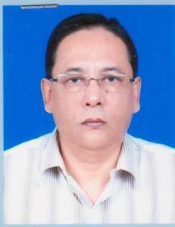 | DR. MD. ABDUL MUNIM CHOWDHURY  F/Name:  M/Name:  BM & DC Reg. No:  NID:  Cell:  Address: Medical Quarter Chowhalla Sylhet  Blood Group:
8 | Voter No  LM-6500008  No Image | DR. M.A GAFFOR  F/Name:  M/Name:  BM & DC Reg. No:  NID:  Cell:  Address: Resident Surgeon Osmani Medical College Sylhet  Blood Group:
9 | Voter No  LM-6500009  No Image | DR. MD. MATINOR RASHID CHOWDHURY  F/Name:  M/Name:  BM & DC Reg. No:  NID:  Cell:  Address: 5/A, Medical Colony Sylhet  Blood Group:
10 | Voter No  LM-6500010  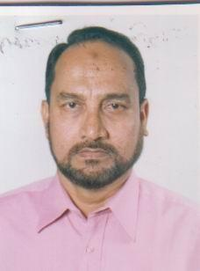 | DR. SAFIR UDDIN AHMED  F/Name:  M/Name:  BM & DC Reg. No:  NID:  Cell:  Address: Rahman Bhaban E.S Road Amberkhana Sylhet  Blood Group:
11 | Voter No  LM-6500011  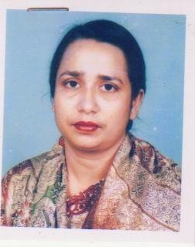 | DR. NILUFAR JAHAN  F/Name:  M/Name:  BM & DC Reg. No:  NID:  Cell:  Address: Rahman Bhaban E.S Road Amberkhana Sylhet  Blood Group:
12 | Voter No  LM-6500012  No Image | DR. MD. OYES AHMED CHOWDHURY  F/Name:  M/Name:  BM & DC Reg. No:  NID:  Cell:  Address: 2/F, Urmee Old Medical College Sylhet  Blood Group:
13 | Voter No  LM-6500013  No Image | DR. JAMILA KHATUN CHOWDHURY  F/Name:  M/Name:  BM & DC Reg. No:  NID:  Cell:  Address: 2/F, Urmee Old Medical College Sylhet  Blood Group:
14 | Voter No  LM-6500014  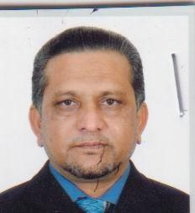 | DR. MD. SHIBBIR AHMED (SHIBLE)  F/Name:  M/Name:  BM & DC Reg. No:  NID:  Cell:  Address: Community Medicine Dept. Osmani Medical College Sylhet  Blood Group:
15 | Voter No  LM-6500015  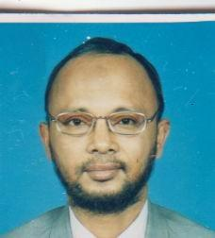 | DR. MD. ISMAIL PATWARY  F/Name:  M/Name:  BM & DC Reg. No:  NID:  Cell:  Address: Consultant Medical Colony Sadar Hospital Sylhet  Blood Group:
16 | Voter No  LM-6500016  No Image | DR. MD. AFTAB HOSSAIN  F/Name:  M/Name:  BM & DC Reg. No:  NID:  Cell:  Address: 1/C, Medical Colony Sylhet  Blood Group:
17 | Voter No  LM-6500017  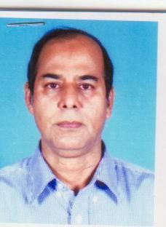 | DR. MD. HARUNUR RASHID  F/Name:  M/Name:  BM & DC Reg. No:  NID:  Cell:  Address: Mirabazar Sylhet  Blood Group:
18 | Voter No  LM-6500018  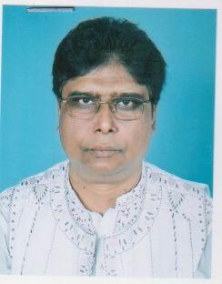 | DR. BANADIP LAL DAS  F/Name:  M/Name:  BM & DC Reg. No:  NID:  Cell:  Address: Lal Brothers Villa, Skeikhghet, Sylhet  Blood Group:
19 | Voter No  LM-6500019  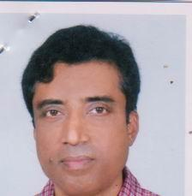 | DR. SYED MAHMUD HASAN  F/Name:  M/Name:  BM & DC Reg. No:  NID:  Cell:  Address: 37, Housing Estate Amberkhana Sylhet  Blood Group:
20 | Voter No  LM-6500020  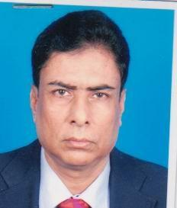 | DR. SUDHAMAY MAJUMDER  F/Name:  M/Name:  BM & DC Reg. No:  NID:  Cell:  Address: Niloy 1, Chouhatta Sylhet  Blood Group:
21 | Voter No  LM-6500021  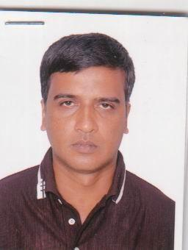 | DR. MOHITOSH RANJAN DAS  F/Name:  M/Name:  BM & DC Reg. No:  NID:  Cell:  Address: Radiology Dept. Osmani Medical College Sylhet  Blood Group:
22 | Voter No  LM-6500022  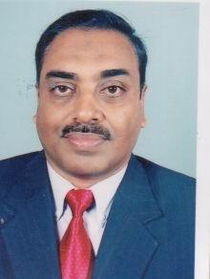 | DR. MOHAMMED REZAUL KARIM  F/Name:  M/Name:  BM & DC Reg. No:  NID:  Cell:  Address: 2/C, New Medical Quarter Kazalsha Sylhet  Blood Group:
23 | Voter No  LM-6500023  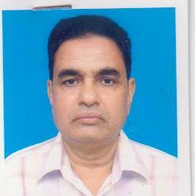 | DR. SYED BURHAN UDDIN  F/Name:  M/Name:  BM & DC Reg. No:  NID:  Cell:  Address: 346, Shuvcha  Sheikhat  Sylhet  Blood Group:
24 | Voter No  LM-6500024  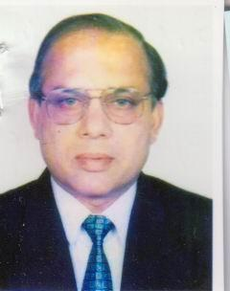 | DR. AKM. HAFIZ  F/Name:  M/Name:  BM & DC Reg. No:  NID:  Cell:  Address: 36, H/E, Abasir Area Amberkhana Sylhet  Blood Group:
25 | Voter No  LM-6500025  No Image | DR. ENAMUL KABIR CHOWDHURY  F/Name:  M/Name:  BM & DC Reg. No:  NID:  Cell:  Address: Taltala Sylhet  Blood Group:
26 | Voter No  LM-6500026  No Image | DR. AMINA BEGUM  F/Name:  M/Name:  BM & DC Reg. No:  NID:  Cell:  Address: House-1, Road-5, Block-A Sylhet  Blood Group:
27 | Voter No  LM-6500027  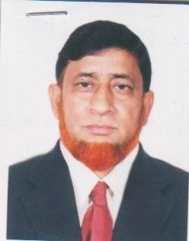 | DR. MD. MANAJIR ALI  F/Name:  M/Name:  BM & DC Reg. No:  NID:  Cell:  Address: Associate Professor Of Pead Osmani Medical College Sylhet  Blood Group:
28 | Voter No  LM-6500028  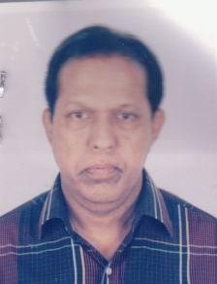 | DR. M.A MATIN  F/Name:  M/Name:  BM & DC Reg. No:  NID:  Cell:  Address: Medical Colony Sylhet  Blood Group:
29 | Voter No  LM-6500029  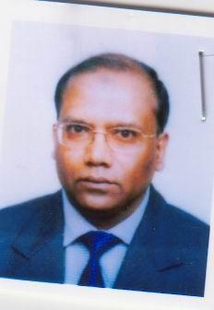 | DR. MD. MASHUQUR RAHMAN CHOWDHURY  F/Name:  M/Name:  BM & DC Reg. No:  NID:  Cell:  Address: 64, H/F, Ambarkhana Sylhet  Blood Group:
30 | Voter No  LM-6500030  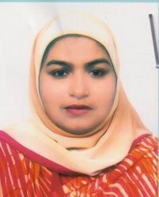 | DR. GULSHAN E JAHAN  F/Name:  M/Name:  BM & DC Reg. No:  NID:  Cell:  Address: 64, H/F, Ambarkhana Sylhet  Blood Group:
31 | Voter No  LM-6500031  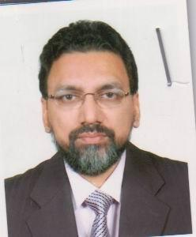 | DR. SHAHRIER HUSSAIN CHOWDHURY  F/Name:  M/Name:  BM & DC Reg. No:  NID:  Cell:  Address: 50/A, Amberkhana Borobazar Sylhet  Blood Group:
32 | Voter No  LM-6500032  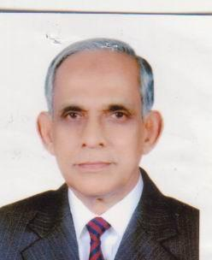 | DR. AZIZUR RAHMAN JOADER  F/Name:  M/Name:  BM & DC Reg. No:  NID:  Cell:  Address: 92, H/E, Amberkhana Sylhet  Blood Group:
33 | Voter No  LM-6500033  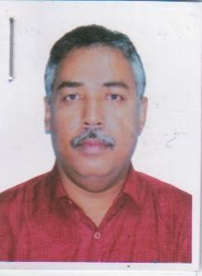 | DR. MD. SHAMIMUR RAHMAN  F/Name:  M/Name:  BM & DC Reg. No:  NID:  Cell:  Address: House-4, Road-26, Block-D Shahjalal U/S Sylhet  Blood Group:
34 | Voter No  LM-6500034  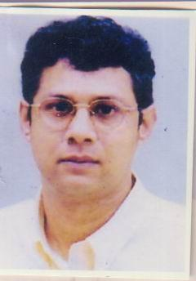 | DR. MD. NAZMUL ISLAM  F/Name:  M/Name:  BM & DC Reg. No:  NID:  Cell:  Address: Ishaque-14, Poobaho Telihaor Sylhet  Blood Group:
35 | Voter No  LM-6500035  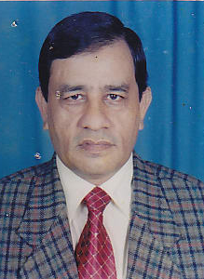 | DR. KAZI AKTAR UDDIN  F/Name:  M/Name:  BM & DC Reg. No:  NID:  Cell:  Address: Medical Officer ENT OPD. Osmani Medical College Sylhet  Blood Group:
36 | Voter No  LM-6500036  No Image | DR. REHANA CHOWDHURY  F/Name:  M/Name:  BM & DC Reg. No:  NID:  Cell:  Address: House-4, Road-14, Block-A Shahjalal U/S Sylhet  Blood Group:
37 | Voter No  LM-6500037  No Image | DR. ALAUDDIN AHMED  F/Name:  M/Name:  BM & DC Reg. No:  NID:  Cell:  Address: House-4, Road-14, Block-A Shahjalal U/S Sylhet  Blood Group:
38 | Voter No  LM-6500038  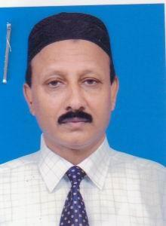 | DR. MUSADDEAQUE CHOWDHURY  F/Name:  M/Name:  BM & DC Reg. No:  NID:  Cell:  Address: Medical Officer Osmani Medical College Sylhet  Blood Group:
39 | Voter No  LM-6500039  No Image | DR. SYEDA RAJNA BEGUM  F/Name:  M/Name:  BM & DC Reg. No:  NID:  Cell:  Address: 96, Mojumdari Sylhet  Blood Group:
40 | Voter No  LM-6500040  No Image | DR. A.K. MUZIBUL HAQUE  F/Name:  M/Name:  BM & DC Reg. No:  NID:  Cell:  Address: 96, Mojumdari Sylhet  Blood Group:
41 | Voter No  LM-6500041  No Image | DR. AYESHA RAHIM  F/Name:  M/Name:  BM & DC Reg. No:  NID:  Cell:  Address: 21, Surma Abashik Prokalpa Akhalia Sylhet  Blood Group:
42 | Voter No  LM-6500042  No Image | DR. A.T.M.A JALIL  F/Name:  M/Name:  BM & DC Reg. No:  NID:  Cell:  Address: 21, Surma Abashik Prokalpa Akhalia Sylhet  Blood Group:
43 | Voter No  LM-6500043  No Image | DR. MD. SHOFIUL AZAM  F/Name:  M/Name:  BM & DC Reg. No:  NID:  Cell:  Address: Curator, Anatomy Dept. Osmani Medical College Sylhet  Blood Group:
44 | Voter No  LM-6500044  No Image | DR. SHAHANA FERDOUS CHOWDHURY  F/Name:  M/Name:  BM & DC Reg. No:  NID:  Cell:  Address: 2-A, Urmee Old Medical Colony Sylhet  Blood Group:
45 | Voter No  LM-6500045  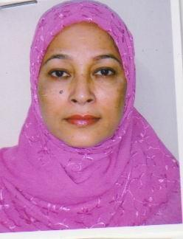 | DR. JAHANARA BEGUM  F/Name:  M/Name:  BM & DC Reg. No:  NID:  Cell:  Address: Niloy-60 Darga Gate Sylhet  Blood Group:
46 | Voter No  LM-6500046  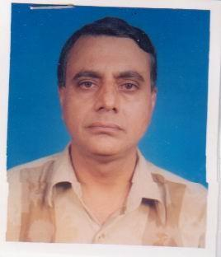 | DR. LUTFE ELAHI FAROOQUI  F/Name:  M/Name:  BM & DC Reg. No:  NID:  Cell:  Address: Niloy-60 Darga Gate Sylhet  Blood Group:
47 | Voter No  LM-6500047  No Image | DR. MD. ABDUS SABUR  F/Name:  M/Name:  BM & DC Reg. No:  NID:  Cell:  Address: Asstant Professor S. Osmani Medical College Sylhet  Blood Group:
48 | Voter No  LM-6500048  No Image | DR. ABDUR RASHID  F/Name:  M/Name:  BM & DC Reg. No:  NID:  Cell:  Address: 1/D, New Medical Colony Kazalhaor Sylhet  Blood Group:
49 | Voter No  LM-6500049  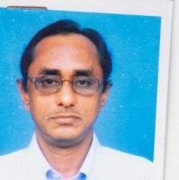 | DR. ABDUL KARIM CHOWDHURY  F/Name:  M/Name:  BM & DC Reg. No:  NID:  Cell:  Address: Kanihati, House-12 3, Nurami R/A Sylhet  Blood Group:
50 | Voter No  LM-6500050  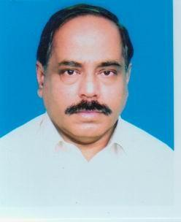 | DR. GOPAL SANKAR DEY  F/Name:  M/Name:  BM & DC Reg. No:  NID:  Cell:  Address: S. Osmani Medical College Sylhet  Blood Group:  E X P I R E D
51 | Voter No  LM-6500051  No Image | DR. MD. SAKHOWAT HOSSAIN CHOWDHURY  F/Name:  M/Name:  BM & DC Reg. No:  NID:  Cell:  Address: 7/A, Mitali Building Medical Colony Sylhet  Blood Group:
52 | Voter No  LM-6500052  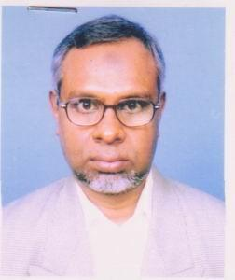 | DR. MD. MATIUR RAHMAN  F/Name:  M/Name:  BM & DC Reg. No:  NID:  Cell:  Address: 7B, Metali Old Medical Colony Sylhet  Blood Group:
53 | Voter No  LM-6500053  No Image | DR. MD. SANUR ALI  F/Name:  M/Name:  BM & DC Reg. No:  NID:  Cell:  Address: 25/4, Nurani R/A Subid Bazar Sylhet  Blood Group:
54 | Voter No  LM-6500054  No Image | DR. MUZTABA ANWARUZZAMAN  F/Name:  M/Name:  BM & DC Reg. No:  NID:  Cell:  Address: Asstant Registrer S. Osmani Medical College Sylhet  Blood Group:
55 | Voter No  LM-6500055  No Image | DR. MD. HELAL UDDIN  F/Name:  M/Name:  BM & DC Reg. No:  NID:  Cell:  Address: 4/D, Kakali Medical Colony Sylhet  Blood Group:
56 | Voter No  LM-6500056  No Image | DR. MD. MATIUR RAHMAN  F/Name:  M/Name:  BM & DC Reg. No:  NID:  Cell:  Address: 7/C, Mitali Old Medical Colony Sylhet  Blood Group:
57 | Voter No  LM-6500057  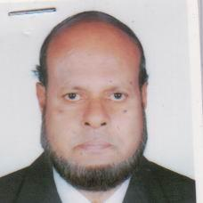 | DR. C.M. NOOR AHMED  F/Name:  M/Name:  BM & DC Reg. No:  NID:  Cell:  Address: 41/4, Jalalabad R/A Subid Bazar Sylhet  Blood Group:
58 | Voter No  LM-6500058  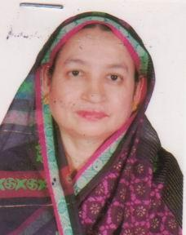 | DR. Z.S. MANSURA KHATUN  F/Name:  M/Name:  BM & DC Reg. No:  NID:  Cell:  Address: 41/4, Jalalabad R/A Subid Bazar Sylhet  Blood Group:
59 | Voter No  LM-6500059  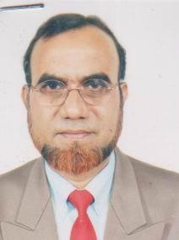 | DR. MD. ABU YOUSUF BHUIYAN  F/Name:  M/Name:  BM & DC Reg. No:  NID:  Cell:  Address: Barnali, 6/B Medical Colony Sylhet  Blood Group:
60 | Voter No  LM-6500060  No Image | DR. DEBOJGOTI DAS  F/Name:  M/Name:  BM & DC Reg. No:  NID:  Cell:  Address: Chouhatta Sylhet  Blood Group:
61 | Voter No  LM-6500061  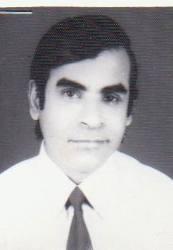 | DR. PRAMATHESH KUMAR DAS  F/Name:  M/Name:  BM & DC Reg. No:  NID:  Cell:  Address: Emergency Medical Officer S. Osmani Medical College Sylhet  Blood Group:
62 | Voter No  LM-6500062  No Image | DR. MD. MAHMUDUR RAHMAN  F/Name:  M/Name:  BM & DC Reg. No:  NID:  Cell:  Address: Emergency Medical Officer S. Osmani Medical College Sylhet  Blood Group:
63 | Voter No  LM-6500063  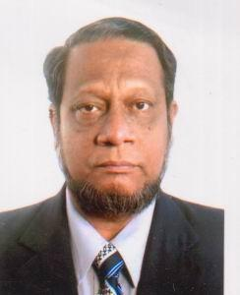 | DR. MD. MUSABBIR HUSSAIN  F/Name:  M/Name:  BM & DC Reg. No:  NID:  Cell:  Address: Hussain Monzil Zindabazar Sylhet  Blood Group:
64 | Voter No  LM-6500064  No Image | DR. MD. AZIR UDDIN AHMED  F/Name:  M/Name:  BM & DC Reg. No:  NID:  Cell:  Address: Islam Manzil Lama Bazar, Noyapara Sylhet  Blood Group:
65 | Voter No  LM-6500065  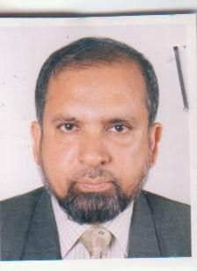 | DR. FAZLUR RAHIM KAISER  F/Name:  M/Name:  BM & DC Reg. No:  NID:  Cell:  Address: 141/11, Kazal Sheh Abasik Alaka Sylhet  Blood Group:
66 | Voter No  LM-6500066  No Image | DR. MD. SHAFIQUR RAHMAN  F/Name:  M/Name:  BM & DC Reg. No:  NID:  Cell:  Address: Ma-Moni Hospital Kumarpara Sylhet  Blood Group:
67 | Voter No  LM-6500067  No Image | DR. MD. ABUL HASHEM CHOWDHURY  F/Name:  M/Name:  BM & DC Reg. No:  NID:  Cell:  Address: 22, Modhushaheed Sylhet  Blood Group:
68 | Voter No  LM-6500068  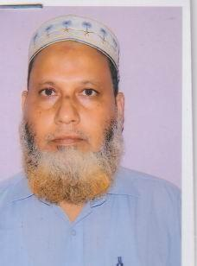 | DR. JAMIL AHMED  F/Name:  M/Name:  BM & DC Reg. No:  NID:  Cell:  Address: 141, Karim Villa Dishari Howapara Sylhet  Blood Group:
69 | Voter No  LM-6500069  No Image | DR. MD. EHTESHAMUL HUQ CHOWDHURY  F/Name:  M/Name:  BM & DC Reg. No:  NID:  Cell:  Address: Niloy-20, Chouhatta, Sylhet  Blood Group:  TRANSFERED to BMA Dhaka City  LM-1405543
70 | Voter No  LM-6500070  No Image | DR. ASHOKE BIJOY DAS GUPTA  F/Name:  M/Name:  BM & DC Reg. No:  NID:  Cell:  Address: Jharna Villa Nowab Road Sylhet  Blood Group:
71 | Voter No  LM-6500071  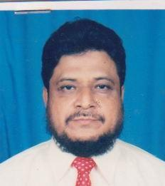 | DR. M.A. LATIF  F/Name:  M/Name:  BM & DC Reg. No:  NID:  Cell:  Address: Medical Officer (Eye OPD) S. Osmani Medical College Sylhet  Blood Group:
72 | Voter No  LM-6500072  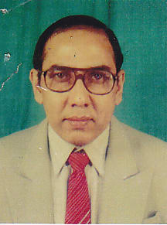 | DR. SK. NIZAM ZAHID HUSSAIN  F/Name:  M/Name:  BM & DC Reg. No:  NID:  Cell:  Address: House-6 Dargah Gate Sylhet  Blood Group:
73 | Voter No  LM-6500073  No Image | DR. MAHMUDA RAHMAN  F/Name:  M/Name:  BM & DC Reg. No:  NID:  Cell:  Address: Forhadkha Pool Shibgonj Sylhet  Blood Group:
74 | Voter No  LM-6500074  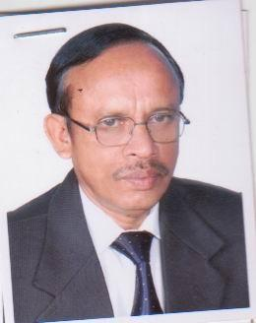 | DR. MD. ZAKARIYA HUSSAIN  F/Name:  M/Name:  BM & DC Reg. No:  NID:  Cell:  Address: 8, Aram Bagh R/S Sylhet  Blood Group:
75 | Voter No  LM-6500075  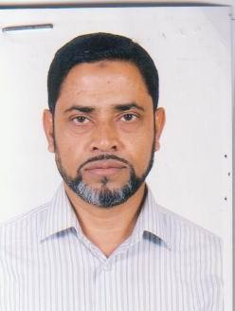 | DR. MD. MOSEH UDDIN CHOWDHURY  F/Name:  M/Name:  BM & DC Reg. No:  NID:  Cell:  Address: 1/B, Surma Old Medical Colony Sylhet  Blood Group:
76 | Voter No  LM-6500076  No Image | DR. SHEKHAR SHUVAN PAL CHOWDHURY  F/Name:  M/Name:  BM & DC Reg. No:  NID:  Cell:  Address: Mirja Jangal Sylhet  Blood Group:
77 | Voter No  LM-6500077  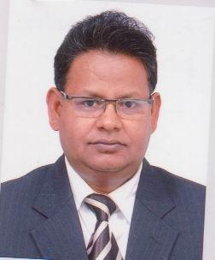 | DR. NIL KANTA PAUL  F/Name:  M/Name:  BM & DC Reg. No:  NID:  Cell:  Address: Rediologist Sadar Hospital Sylhet  Blood Group:
78 | Voter No  LM-6500078  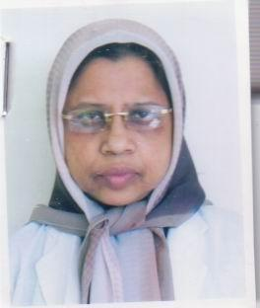 | DR. MRS. FARHAT MAHAL  F/Name:  M/Name:  BM & DC Reg. No:  NID:  Cell:  Address: Dorga Mohalla Sylhet  Blood Group:
79 | Voter No  LM-6500079  No Image | DR. NASIM AHMED  F/Name:  M/Name:  BM & DC Reg. No:  NID:  Cell:  Address: Darga Gate (East) Sylhet  Blood Group:
80 | Voter No  LM-6500080  No Image | DR. M.A. MATIN  F/Name:  M/Name:  BM & DC Reg. No:  NID:  Cell:  Address: Darga Mahalla Sylhet  Blood Group:
81 | Voter No  LM-6500081  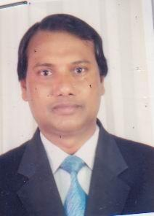 | DR. N.H.A. QURESHI  F/Name:  M/Name:  BM & DC Reg. No:  NID:  Cell:  Address: Sheik House Sheik Para, Sylhet.  Blood Group:  E X P I R E D
82 | Voter No  LM-6500082  No Image | DR. FARUQUE AHMED CHOWDHURY  F/Name:  M/Name:  BM & DC Reg. No:  NID:  Cell:  Address: Faruk Manjil 50, Baro Bazar Amberkhana Sylhet  Blood Group:
83 | Voter No  LM-6500083  No Image | DR. MD. SHAHID AHMED  F/Name:  M/Name:  BM & DC Reg. No:  NID:  Cell:  Address: Vill-Nayogram P.O+P.S-Beani Bazar Sylhet  Blood Group:
84 | Voter No  LM-6500084  No Image | DR. A.K.M. DAUD  F/Name:  M/Name:  BM & DC Reg. No:  NID:  Cell:  Address: 22/A, Nauasank Sylhet  Blood Group:
85 | Voter No  LM-6500085  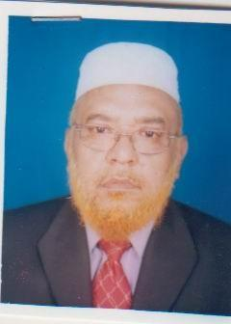 | DR. IQBAL HUSSAIN CHOWDHURY  F/Name:  M/Name:  BM & DC Reg. No:  NID:  Cell:  Address: 91, Azad Mirbox Tolla Sylhet  Blood Group:
86 | Voter No  LM-6500086  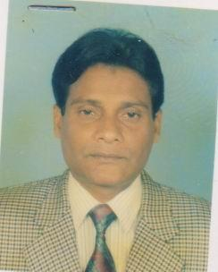 | DR. MD. BADRUZZAMAN LASKER  F/Name:  M/Name:  BM & DC Reg. No:  NID:  Cell:  Address: Medical Officer (Eye) Sylhet Medical College Sylhet  Blood Group:
87 | Voter No  LM-6500087  No Image | DR. AYESHA ROFIQUE CHOWDHURY  F/Name:  M/Name:  BM & DC Reg. No:  NID:  Cell:  Address: 45/8A, Jalalabad R/A Sylhet  Blood Group:
88 | Voter No  LM-6500088  No Image | DR. SHIBA BRATA HALDER  F/Name:  M/Name:  BM & DC Reg. No:  NID:  Cell:  Address: Medical Officer Thana Health Complex Jogannathpur Sylhet  Blood Group:
89 | Voter No  LM-6500089  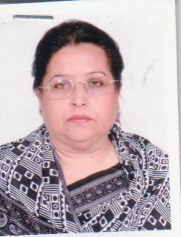 | DR. SULTANA AZIZ  F/Name:  M/Name:  BM & DC Reg. No:  NID:  Cell:  Address: Patantula Sylhet  Blood Group:
90 | Voter No  LM-6500090  No Image | DR. RAJENDRA TRIPURA  F/Name:  M/Name:  BM & DC Reg. No:  NID:  Cell:  Address:  Blood Group:  TRANSFERED to BMA Dhaka City  LM-1405543
91 | Voter No  LM-6500091  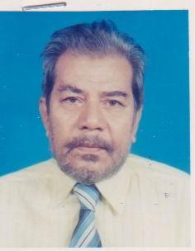 | DR. MD. ALTAFUR RAHMAN  F/Name:  M/Name:  BM & DC Reg. No:  NID:  Cell:  Address: Dnopadighi North Sylhet  Blood Group:
92 | Voter No  LM-6500092  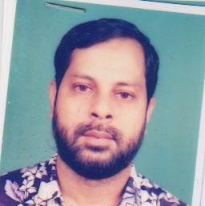 | DR. MURSHED AHMED CHOWDHURY  F/Name:  M/Name:  BM & DC Reg. No:  NID:  Cell:  Address: Lamabazar, Sylhet.  Blood Group:
93 | Voter No  LM-6500093  No Image | DR. DEWAN ETIMUR RAZA CHOWDHURY  F/Name:  M/Name:  BM & DC Reg. No:  NID:  Cell:  Address: Vill-Satak P.O-Nabigonj Habigonj Sylhet  Blood Group:
94 | Voter No  LM-6500094  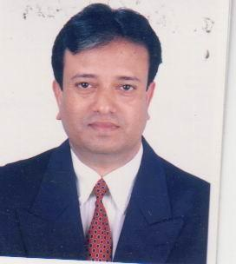 | DR. MD. SHIBLI KHAN  F/Name:  M/Name:  BM & DC Reg. No:  NID:  Cell:  Address: Swornali-13, Block-C Bharthokhola Sylhet  Blood Group:
95 | Voter No  LM-6500095  No Image | DR. MUSTAFA SHAHZAMAN CHOWDHURY  F/Name:  M/Name:  BM & DC Reg. No:  NID:  Cell:  Address: Shukria Zindabazar Sylhet  Blood Group:
96 | Voter No  LM-6500096  No Image | DR. DULAL CHANDRA PODDER  F/Name:  M/Name:  BM & DC Reg. No:  NID:  Cell:  Address: C/O. Sadhu Babu Lal Boothes, House Sheik Ghat, Sylhet.  Blood Group:
97 | Voter No  LM-6500097  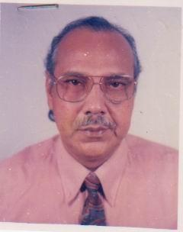 | DR. MD. ABDUL HYE CHOWDHURY  F/Name:  M/Name:  BM & DC Reg. No:  NID:  Cell:  Address: 34, Saief Khan Road Subid Bazar Sylhet  Blood Group:
98 | Voter No  LM-6500098  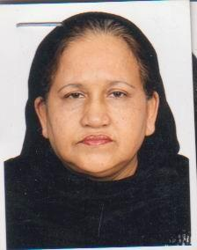 | DR. MRS. ANWARA BEGUM  F/Name:  M/Name:  BM & DC Reg. No:  NID:  Cell:  Address: 34, Saief Khan Road Subid Bazar Sylhet  Blood Group:
99 | Voter No  LM-6500099  No Image | DR. GAYATRI DEY  F/Name:  M/Name:  BM & DC Reg. No:  NID:  Cell:  Address: Central Pharmacy Choulta Sylhet  Blood Group:
100 | Voter No  LM-6500100  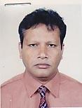 | DR. HIMANGSHU LAL ROY  F/Name:  M/Name:  BM & DC Reg. No:  NID:  Cell:  Address: Meghna B/S Dariapara Jallarpar Sylhet  Blood Group:
101 | Voter No  LM-6500101  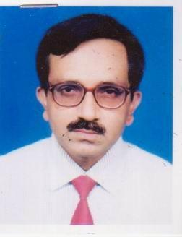 | DR. SABYASACHI ROY  F/Name:  M/Name:  BM & DC Reg. No:  NID:  Cell:  Address: Kazalshah, South Sylhet  Blood Group:
102 | Voter No  LM-6500102  No Image | DR. SUBHANGSHJ RANJAN DEY  F/Name:  M/Name:  BM & DC Reg. No:  NID:  Cell:  Address: Nabab Road Kazalshah Sylhet  Blood Group:
103 | Voter No  LM-6500103  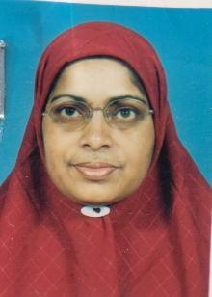 | DR. SHAMSUN NAHAR BEGUM  F/Name: Late Md. Ameen Al  M/Name:  BM & DC Reg. No:  NID:  Cell:  Address: M A G Osmani Medical College, Mitaly-8, Subid Bazar, Sylhet  Blood Group:
104 | Voter No  LM-6500104  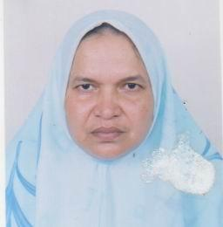 | DR. SHAMSUN NAHAR BEGUM  F/Name:  M/Name:  BM & DC Reg. No:  NID:  Cell:  Address: 1/B, Surma Bld. Medical Colony Sylhet  Blood Group:
105 | Voter No  LM-6500105  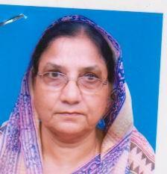 | DR. ASIA KHATUN CHOWDHURY  F/Name:  M/Name:  BM & DC Reg. No:  NID:  Cell:  Address: Beg Kutir Dariapara Sylhet  Blood Group:
106 | Voter No  LM-6500106  No Image | DR. MD. NAZMUL HOQUE  F/Name:  M/Name:  BM & DC Reg. No:  NID:  Cell:  Address: 12, Housing Estate Sylhet  Blood Group:
107 | Voter No  LM-6500107  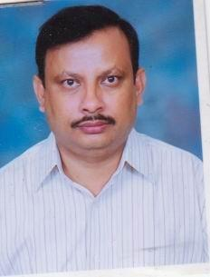 | DR. MD. MAMUNUR RASHID  F/Name:  M/Name:  BM & DC Reg. No:  NID:  Cell:  Address: TB. Clinic Sylhet  Blood Group:
108 | Voter No  LM-6500108  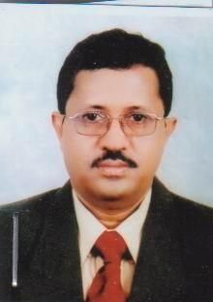 | DR. KALLOL BIJOY KAR  F/Name:  M/Name:  BM & DC Reg. No:  NID:  Cell:  Address: Dhupadighir Par Sylhet  Blood Group:
109 | Voter No  LM-6500109  No Image | DR. SAIDUL ISLAM  F/Name:  M/Name:  BM & DC Reg. No:  NID:  Cell:  Address: Shaheed Shamsuddin Hospital Sylhet  Blood Group:
110 | Voter No  LM-6500110  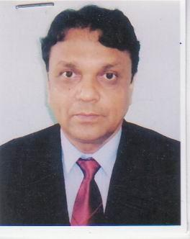 | DR. FAISAL AHMED  F/Name:  M/Name:  BM & DC Reg. No:  NID:  Cell:  Address: 3/A, Waves East Darga Gate, Chandontula Sadar Sylhet  Blood Group:
111 | Voter No  LM-6500111  No Image | DR. MD. ATIQUR RAHMAN  F/Name:  M/Name:  BM & DC Reg. No:  NID:  Cell:  Address: Dept. Of Surgery Sylhet MAGO Medical College Sylhet  Blood Group:
112 | Voter No  LM-6500112  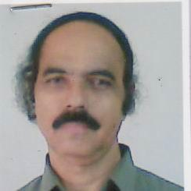 | DR. MRIGEN KUMAR DAS CHOWDHURY  F/Name:  M/Name:  BM & DC Reg. No:  NID:  Cell:  Address: Associate Professor Paedi Surgery Osmani Medical College Sylhet  Blood Group:
113 | Voter No  LM-6500113  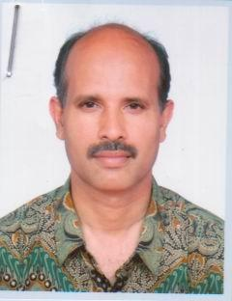 | DR. KHAIR AHMED CHOWDHURY  F/Name:  M/Name:  BM & DC Reg. No:  NID:  Cell:  Address: Kalitola Sylhet  Blood Group:
114 | Voter No  LM-6500114  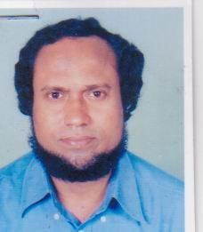 | DR. MD. MUZAMMEL HUSSAIN  F/Name:  M/Name:  BM & DC Reg. No:  NID:  Cell:  Address: R.S. (ENT) MAG, Osmani Medical College Sylhet  Blood Group:
115 | Voter No  LM-6500115  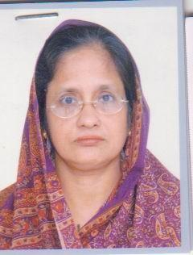 | DR. NAJMA BEGUM  F/Name:  M/Name:  BM & DC Reg. No:  NID:  Cell:  Address: House-119 Mojumder Kamal Bagan Sylhet  Blood Group:
116 | Voter No  LM-6500116  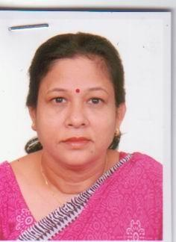 | DR. PROLINA BALA DEBI  F/Name:  M/Name:  BM & DC Reg. No:  NID:  Cell:  Address: Puraton Medical Colony Sylhet  Blood Group:
117 | Voter No  LM-6500117  No Image | DR. AMINUDDIN CHOUDHURY  F/Name:  M/Name:  BM & DC Reg. No:  NID:  Cell:  Address: Assistant Professor PED Osmani Medical College Sylhet  Blood Group:
118 | Voter No  LM-6500118  No Image | DR. BACHIRUL ISLAM BHUIYAN  F/Name:  M/Name:  BM & DC Reg. No:  NID:  Cell:  Address: Medical Officer Jaganathpara Thana Health Complex Sylhet  Blood Group:
119 | Voter No  LM-6500119  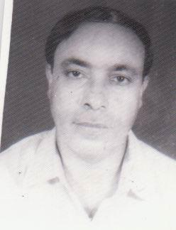 | DR. PRODYOT KUMAR BHATTACHAREYGA  F/Name:  M/Name:  BM & DC Reg. No:  NID:  Cell:  Address: 1, Medical Colony Sylhet  Blood Group:
120 | Voter No  LM-6500120  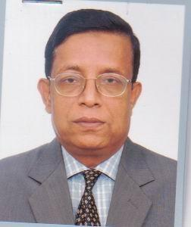 | DR. MD. ABUL AHBAB  F/Name:  M/Name:  BM & DC Reg. No:  NID:  Cell:  Address: Associate Professor Medicine MAG Osmani Medical College Sylhet  Blood Group:
121 | Voter No  LM-6500121  No Image | DR. GOLAM KIBRIA CHOWDHURY  F/Name:  M/Name:  BM & DC Reg. No:  NID:  Cell:  Address: Principal Sylhet MAG Osmani Medical College Sylhet  Blood Group:
122 | Voter No  LM-6500122  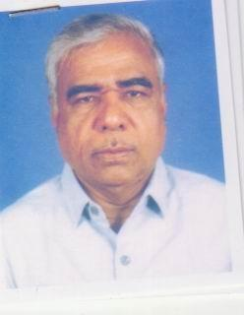 | DR. NIRANJAN KUMAR PAUL  F/Name:  M/Name:  BM & DC Reg. No:  NID:  Cell:  Address: Sylhet MAG Osmani Medical College Sylhet  Blood Group:
123 | Voter No  LM-6500123  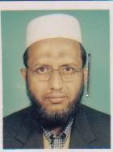 | DR. MD.ARIF MIAH  F/Name:  M/Name:  BM & DC Reg. No:  NID:  Cell:  Address: 206, LVA Koti Bhatalia Sylhet  Blood Group:
124 | Voter No  LM-6500124  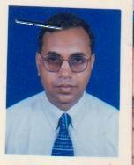 | DR. MURUL RANJAN GHOSH  F/Name:  M/Name:  BM & DC Reg. No:  NID:  Cell:  Address: 3/4, Ralal Shah Sylhet  Blood Group:
125 | Voter No  LM-6500125  No Image | DR. SHAMEEM ANWARUL HAQUE  F/Name:  M/Name:  BM & DC Reg. No:  NID:  Cell:  Address: 11, Housing Estate Amberkhana Sylhet  Blood Group:
126 | Voter No  LM-6500126  No Image | DR. SYED ZAFRUL HUSAIN  F/Name:  M/Name:  BM & DC Reg. No:  NID:  Cell:  Address: Stadium Market Sylhet  Blood Group:
127 | Voter No  LM-6500127  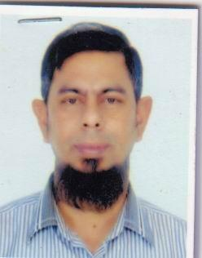 | DR. A.F.M. NAZMUL ISLAM  F/Name:  M/Name:  BM & DC Reg. No:  NID:  Cell:  Address: 76, Provati Purbopir Moholla Sylhet.  Blood Group:
128 | Voter No  LM-6500128  No Image | DR. MOHAFIZUL HOQUE KHAN  F/Name:  M/Name:  BM & DC Reg. No:  NID:  Cell:  Address: Nuclear Medical Centre P.O. Box-67 Sylhet  Blood Group:
129 | Voter No  LM-6500129  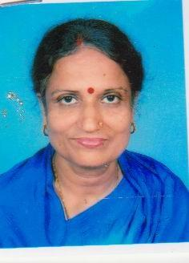 | DR. IVY PURKAYASTHA  F/Name:  M/Name:  BM & DC Reg. No:  NID:  Cell:  Address: C/O-Sudip Pharmacy Dophadigir, Uttarpar Sylhet  Blood Group:
130 | Voter No  LM-6500130  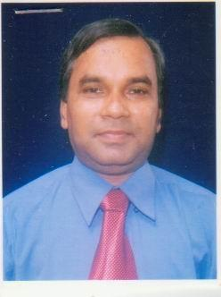 | DR. BIKASH SIKDER  F/Name:  M/Name:  BM & DC Reg. No:  NID:  Cell:  Address: Focus-9, Baluchar Durgabari Sylhet  Blood Group:
131 | Voter No  LM-6500131  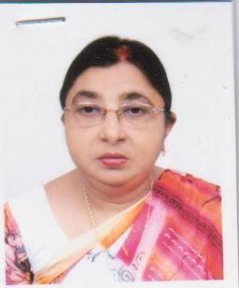 | DR. DIPTI RANI SAHA  F/Name:  M/Name:  BM & DC Reg. No:  NID:  Cell:  Address: 17/A, Rajani Gandha R/A Tikorpara, Sylhet.  Blood Group:
132 | Voter No  LM-6500132  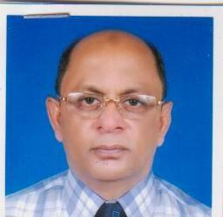 | DR. MD. BADRUL HOQUE RUKAN  F/Name:  M/Name:  BM & DC Reg. No:  NID:  Cell:  Address: 57, Paira Jubed Monjil Darga Mohalla Sylhet  Blood Group:
133 | Voter No  LM-6500133  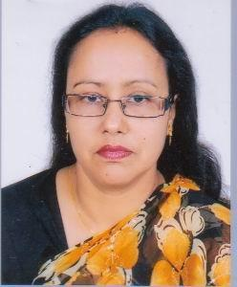 | DR. BEGUM LUTFUN NAHAR  F/Name:  M/Name:  BM & DC Reg. No:  NID:  Cell:  Address: Jubed Monjil 57, Parir, Jarpar Dargah Moholla, Sylhet.  Blood Group:
134 | Voter No  LM-6500134  No Image | DR. FARID AHMED CHOWDHURY  F/Name:  M/Name:  BM & DC Reg. No:  NID:  Cell:  Address: Associate Professor, Radiotheraphy Dept. Osmani Medical College, Sylhet  Blood Group:
135 | Voter No  LM-6500135  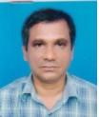 | DR. RUKON UDDIN AHMED  F/Name: Hazi Abul Kasem  M/Name:  BM & DC Reg. No:  NID:  Cell:  Address: Emergency Medical Officer Dept. Osmani Medical College Sylhet  Blood Group:
136 | Voter No  LM-6500136  No Image | DR. IBRAHIM ALI  F/Name:  M/Name:  BM & DC Reg. No:  NID:  Cell:  Address: 12, Chayanirh Lamabazar, Saraspur, Sylhet  Blood Group:
137 | Voter No  LM-6500137  No Image | DR. REZINA MUSTARIN  F/Name:  M/Name:  BM & DC Reg. No:  NID:  Cell:  Address: 24/C, Main Road Shahjalal Uposhor Sylhet  Blood Group:
138 | Voter No  LM-6500138  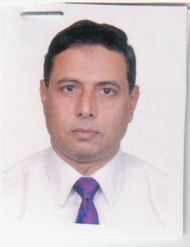 | DR. MD. MUZIBUR RAHMAN  F/Name:  M/Name:  BM & DC Reg. No:  NID:  Cell:  Address: 79, Mitali Residence Area Raynagar Sylhet  Blood Group:
139 | Voter No  LM-6500139  No Image | DR. SHAIEK AZIZ CHOWDHURY  F/Name:  M/Name:  BM & DC Reg. No:  NID:  Cell:  Address: 57, Paira Dargha Jharnarpar Sylhet  Blood Group:
140 | Voter No  LM-6500140  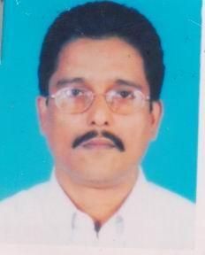 | DR. MD. SHAH NEWAZ CHOWDHURY  F/Name:  M/Name:  BM & DC Reg. No:  NID:  Cell:  Address: 4/1, Kazalshah Ground Floor Sylhet.  Blood Group:
141 | Voter No  LM-6500141  No Image | DR. A.Z.M. SHAKHAWAT HOSSAIN  F/Name:  M/Name:  BM & DC Reg. No:  NID:  Cell:  Address: Associate Professor, Surgery Osmani Medical College Sylhet  Blood Group:  TRANSFERED to BMA Dhaka City  LM-1405543
142 | Voter No  LM-6500142  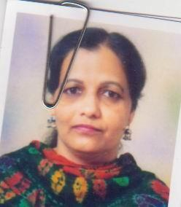 | DR. SHAHINA BEGUM  F/Name: Late Ma. Haq  M/Name:  BM & DC Reg. No:  NID:  Cell:  Address: 4/1, Jakalshah Sylhet  Blood Group:
143 | Voter No  LM-6500143  No Image | DR. HAMIDA BEGUM  F/Name: Md. Dewan Miah  M/Name:  BM & DC Reg. No:  NID:  Cell:  Address: Hazi Nasibullah Market P.O.-Goala Bazar Thana : Osmaninagor Sylhet  Blood Group:
144 | Voter No  LM-6500144  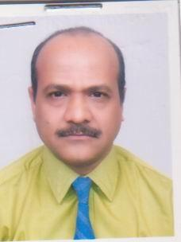 | DR. JOYTIRMAY DATTA  F/Name: Late Jitendra Kumar Datta  M/Name:  BM & DC Reg. No: 10021  NID:  Cell:  Address: 901-20 Teesdale Place,  Scarborough, Ontario  M1L 1L1, Canada.  ((A6, Sonali Bank Staff Quarter  Dariapara Sylhet.)  Blood Group:
145 | Voter No  LM-6500145  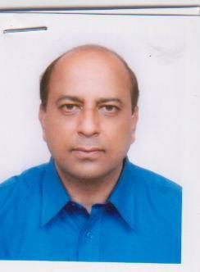 | DR. MD. MOYNUL HAQUE  F/Name: Late Hazi Md. Jubed Ali  M/Name:  BM & DC Reg. No:  NID:  Cell:  Address: 57, Paira Dorua Mohollah Jorner Per Sylhet  Blood Group:
146 | Voter No  LM-6500146  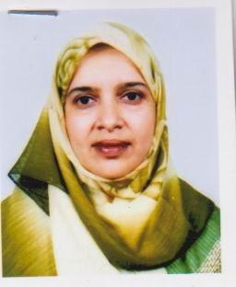 | DR. NASREEN AKHTER  F/Name: Late Md. Belayet Hossain Patwary  M/Name:  BM & DC Reg. No:  NID:  Cell:  Address: 57, Paira Dorua Mohollah Sylhet  Blood Group:
147 | Voter No  LM-6500147  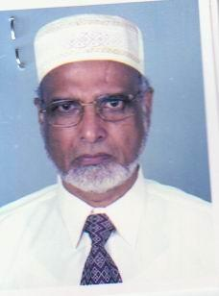 | DR. CPT. MD. BADRUZZAMAN  F/Name: Alhazz Abdul Hashem  M/Name:  BM & DC Reg. No:  NID:  Cell:  Address: 124, Madu Shahid Sylhet  Blood Group:
148 | Voter No  LM-6500148  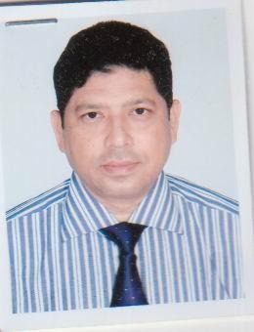 | DR. SYED MOHAMMAD KHOSRU  F/Name: Syed Saiful Rahman  M/Name:  BM & DC Reg. No:  NID:  Cell:  Address: Malancho' 42, Ever Green Jherjheri Para Sylhet  Blood Group:
149 | Voter No  LM-6500149  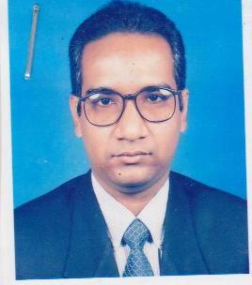 | DR. MD. MAINUL ISLAM CHOUDHURY (NANNA)  F/Name: Md. Muhibul Islam Choudhury  M/Name:  BM & DC Reg. No:  NID:  Cell:  Address: 26, Ever Green Jherjheri Para Sylhet  Blood Group:
150 | Voter No  LM-6500150  No Image | DR. MOHAMMAD ABDUS SALAM  F/Name: Abdul Mannan  M/Name:  BM & DC Reg. No:  NID:  Cell:  Address: 10, Sylvision Road-7, Block-A Shahjalal Upo Shohor Sylhet  Blood Group:
151 | Voter No  LM-6500151  No Image | DR. MD. KAMRUL ALAM  F/Name: Hazi Md. Firuz Miah  M/Name:  BM & DC Reg. No:  NID:  Cell:  Address: Ghurnee, 3B Old Medical Campus Sylhet  Blood Group:
152 | Voter No  LM-6500152  No Image | DR. MOHAMMED SHADRUL ALAM  F/Name:  M/Name:  BM & DC Reg. No:  NID:  Cell:  Address:  Blood Group:  TRANSFERED to BMA Dhaka City  LM-1405543
153 | Voter No  LM-6500153  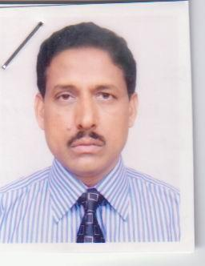 | DR. K.M. AKHTARUZZAMAN  F/Name: Late K.H. Abdul Karim  M/Name:  BM & DC Reg. No:  NID:  Cell:  Address: 1/B, Professors Quarter Osmani Medical College Sylhet  Blood Group:
154 | Voter No  LM-6500154  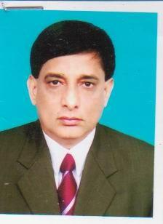 | DR. PROF. PARTHA SARATHI SHOME  F/Name: Late Paresh Chandra Shome  M/Name:  BM & DC Reg. No:  NID:  Cell:  Address: Mg. Osmani Medical College Sylhet  Blood Group:
155 | Voter No  LM-6500155  No Image | DR. MD. ABDUL MALIK  F/Name: Late Md. Amjad Ullah  M/Name:  BM & DC Reg. No:  NID:  Cell:  Address: 2/D, New Medical Colony Osmani Medical College Sylhet  Blood Group:
156 | Voter No  LM-6500156  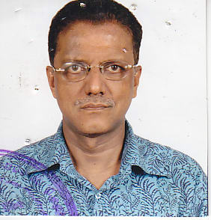 | DR. SHAMSUL ALAM CHOUDHURY  F/Name: Md. Abdul Matin Choudhury  M/Name:  BM & DC Reg. No:  NID:  Cell:  Address: Eye Department Osmani Medical College Sylhet  Blood Group:
157 | Voter No  LM-6500157  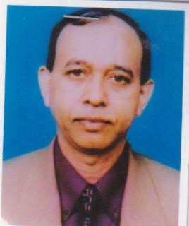 | DR. MD. SIRAJ UDDIN  F/Name: Hafiz Rais Uddin Ahmed  M/Name:  BM & DC Reg. No:  NID:  Cell:  Address: Arnab-2, 1st Floor East Mirer Moidan Sylhet  Blood Group:
158 | Voter No  LM-6500158  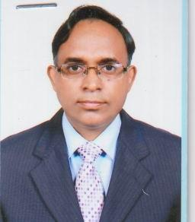 | DR. MD. KAMRUL HUSSAIN AZAD  F/Name: Late Shajidur Rahman  M/Name:  BM & DC Reg. No:  NID:  Cell:  Address: 25, Borobazar R/A, Amberkhana Sylhet  Blood Group:
159 | Voter No  LM-6500159  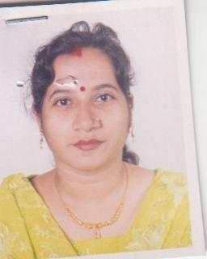 | DR. SURMA ACHARJEE  F/Name: Hiranmay Acharjee  M/Name:  BM & DC Reg. No:  NID:  Cell: 01711311625  Address: 37, Monipuri Rajbari (Laskar Villa) Mirja Jangal, Sylhet-3100.  Blood Group:
160 | Voter No  LM-6500160  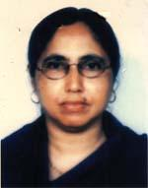 | DR. ROWSHAN ARA BEGUM  F/Name: Md. Habil Ali  M/Name: Mrs. Kauimun Nessa  BM & DC Reg. No: 12177  NID: 9113869900805  Cell: 01711813953  Address: Hospital Quarter , Bianibazar Upazilla Health Complex, Sylhet  Blood Group: A+
161 | Voter No  LM-6500161  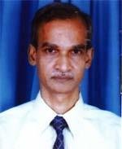 | DR. ISHTIAQUE UL FATTAH  F/Name: Abdul Fattah  M/Name: Siddika Khatun  BM & DC Reg. No: 12711  NID: 9196212244359  Cell: 01819550757  Address: 358, Shuvescha, Sheikghat, Sylhet  Blood Group: AB+
162 | Voter No  LM-6500162  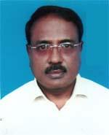 | DR. SUBIR KUMAR DAS  F/Name: Late Surendra Chandra Das  M/Name: Suksiti Das  BM & DC Reg. No: 13632  NID: 9196203121798  Cell: 01711342182  Address: Mohona R.A. Karer Para, Paban Tula, Sylhet  Blood Group: B+
163 | Voter No  LM-6500163  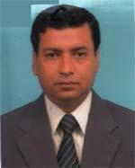 | DR. PRANASHIS SAHA  F/Name: Ramani Mohan Saha  M/Name: Pritikana Saha  BM & DC Reg. No: 15781  NID: 2699040725526  Cell: 01711590494  Address: Department of Urology Sylhet Mag Osmani Medical College  Blood Group: AB+
164 | Voter No  LM-6500164  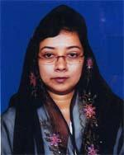 | DR. AKHTER ZAHAN FERDAUSI  F/Name: Md. Golam Mostafa  M/Name: Anowara Begum  BM & DC Reg. No: 23065  NID: 1593525449630  Cell: 01711307493  Address: Rowshan Monjil, Shahporan Gate, Vhadimnagor, Sadar Sylhet  Blood Group: A+
165 | Voter No  LM-6500165  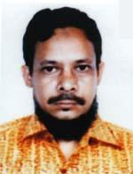 | DR. SYED SAKHAWAT HUSSAIN  F/Name: Late Syed Shamsul Hussain  M/Name: Late Aysha Khatun Chowdhury  BM & DC Reg. No: 20721  NID: 9196211226118  Cell: 01711129252  Address: 211/2, Kazol Shah, New Medical Road, Sylhet  Blood Group: B+
166 | Voter No  LM-6500166  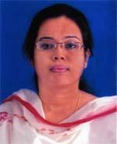 | DR.REHANA FARROQUE  F/Name: W. M. Farroque Khadem  M/Name: Syeda Makbula Sadequa  BM & DC Reg. No: 35830  NID: 9196212237105  Cell: 01711584375  Address: D-2/C, shekhghat, Govt. Quarter, Sylhet  Blood Group: A+
167 | Voter No  LM-6500167  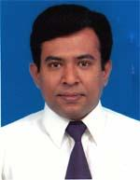 | DR. MD. ASHIKUR RAHMAN MAZUMDER  F/Name: Md. Habibur Rahman Mazumder  M/Name: Syeda Mohsena Begum  BM & DC Reg. No: 25228  NID: 9196212237104  Cell: 01711458835  Address: D-2/C Sheikhghat Govt. Quarter, Sheikhghat, Sylhet  Blood Group: AB+
168 | Voter No  LM-6500168  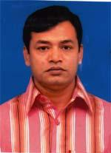 | DR. MOHAMMAD AZIZUR RAHMAN RUMAN  F/Name: Mohammad Eklasur Rahman  M/Name: Mrs. Taslima Khatun  BM & DC Reg. No: 37065  NID: 9196207175432  Cell: 01712134537  Address: Doctors Residence (Besides Trust Bank), Chowhatta, Sylhet  Blood Group: AB+
169 | Voter No  LM-6500169  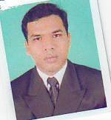 | DR .MOHAMMAD ASHIK ANWAR BAHAR  F/Name: M Abdur Rahim Residential  M/Name:  BM & DC Reg. No:  NID:  Cell:  Address: Surgeon (General) M A G Osmani Medical College Hospital, Sylhet.  Blood Group:
170 | Voter No  LM-6500170  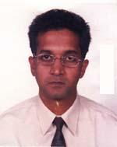 | DR. MD. TAREK AZAD  F/Name: Akhter Ahmed  M/Name: Jahanara Begum  BM & DC Reg. No: 20800  NID: 9196211236049  Cell: 01712148262  Address: Jalalabad Clinic, 124, Modhushahid, Osmani Medical Road, Sylhet  Blood Group: O+
171 | Voter No  LM-6500171  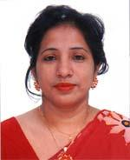 | DR. SHAMIMA AKHTER  F/Name: Dr. Md. Haris Uddin  M/Name: Hasina Begum  BM & DC Reg. No: 22750  NID: 9196211236050  Cell: 01711372612  Address: Jalalabad Clinic, 124, Modhushahid, Osmani Medical Road, Sylhet  Blood Group: O+
172 | Voter No  LM-6500172  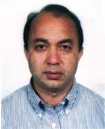 | DR. MD. ABED HOSSAIN  F/Name: Late Md. Sirajul Islam  M/Name: Late Mrs. Ezzater Nessa  BM & DC Reg. No: 20774  NID: 9196201110316  Cell: 01711879766  Address: 48, Rantik, Miah Fazil Chist, Subid Bazar, Sylhet  Blood Group: AB+
173 | Voter No  LM-6500173  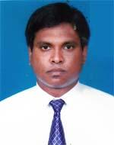 | DR. MD. MIZANUR RAHMAN (PALASH)  F/Name: Mr. Wahidur Rahman  M/Name: Mrs. Rowshon Ara Begum  BM & DC Reg. No: 40234  NID: 9196217292381  Cell: 01819471666  Address: Central Hospital, Hawapara, Sylhet-3100  Blood Group: O+
174 | Voter No  LM-6500174  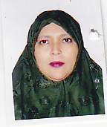 | DR. NADIRA BEGUM  F/Name: Abdul Wazed  M/Name:  BM & DC Reg. No:  NID:  Cell:  Address: 58, Sagar Dighir Par Sylhet  Blood Group:
175 | Voter No  LM-6500175  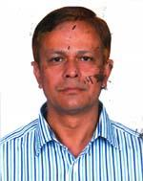 | DR. MONIRUZZAMAN AHMED  F/Name: Late Shamsuzzaman Ahmed  M/Name: Mrs. Morium Begum  BM & DC Reg. No: 16115  NID: 2696653254718  Cell: 01715024714  Address: Asst. Professor, (Midicine), Mag Osmani Medical College, Sylhet  Blood Group: O+
176 | Voter No  LM-6500176  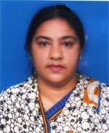 | DR. NAZMA AKHTER KHANAM  F/Name: Md. Haris Uddin  M/Name: Hasina Begum  BM & DC Reg. No: 18023  NID: 9196209210505  Cell: 01711910001  Address: Topoban 100. Akhalia, Sylhet  Blood Group: A+
177 | Voter No  LM-6500177  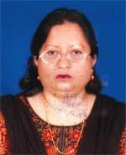 | DR. SHAHANA AHMED  F/Name: Abdur Rashid  M/Name: Late Momtaz Begum  BM & DC Reg. No: 17871  NID: 9196201109664  Cell: 01715544050  Address: 184, Shuvechya, Mia Fazil Chist East Subit Bazar, Sylhet-3100  Blood Group: O+  E X P I R E D
178 | Voter No  LM-6500178  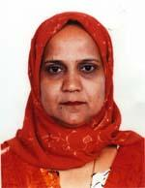 | DR. LUTHFUNNAHER JASMIN  F/Name: Abdur Rashid  M/Name: Late Rahena Begum  BM & DC Reg. No: 20720  NID: 9196211226065  Cell: 01711174222  Address: 211/2 Kajal Shah, New Medical Road, Sylhet  Blood Group: O+
179 | Voter No  LM-6500179  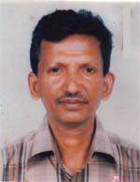 | DR. DIBYA RANJAN DEY  F/Name: Late Digendra Kumar Dey  M/Name: Late Promila Dey  BM & DC Reg. No: 15725  NID: 9196213257765  Cell: 01712219248  Address: College Road, Gagannathpur, Sunamganj  Blood Group: O+
180 | Voter No  LM-6500180  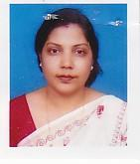 | DR. PIYA BISWAS  F/Name: Dr. Suresh Chandra Biswas  M/Name: Chinmoyee Biswas  BM & DC Reg. No: 22004  NID: 9196203129265  Cell: 01711399717  Address: 8/1, Munsipara (1st Floor), Sylhet  Blood Group: B+
181 | Voter No  LM-6500181  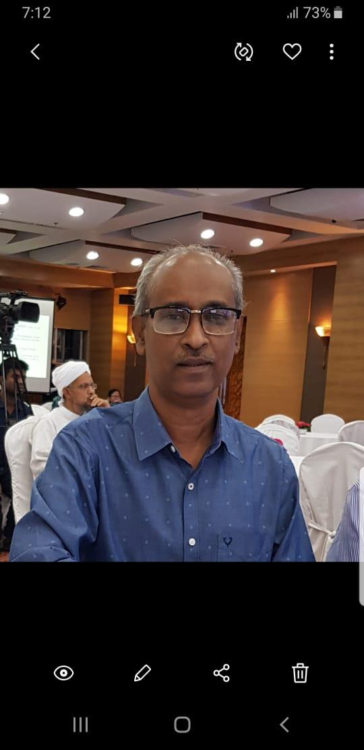 | DR. SATYAKAM CHAKRABORTY  F/Name:  M/Name:  BM & DC Reg. No: 14184  NID: 8692078416  Cell: 01715039504  Address: 16, Baridhara R/A ,Moulvibazar Road , PO- Sreemangal , Dist - Moulvibazar  Blood Group: A-  TRANSFERED to BMA Dhaka City  LM-1405543
182 | Voter No  LM-6500182  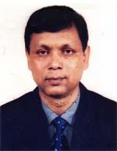 | DR. DILIP KUMAR BHOWMIK  F/Name: Late Debendranath Bhowmik  M/Name: Late Maya Bhowmik  BM & DC Reg. No: 14829  NID: 9196203129266  Cell: 01711349775  Address: 8/1, Munsipara (1st Floor), Sylhet  Blood Group: A+
183 | Voter No  LM-6500183  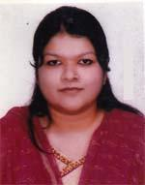 | DR. SHAILA JABEEN  F/Name: Dr. Md. Abdul Hye  M/Name: Mrs. Shirin Akhter  BM & DC Reg. No: 43029  NID: 2650898230132  Cell:  Address: 48, Prantik, Mia Fazil Chist, East Subid Bazar, Sylhet  Blood Group: B+
184 | Voter No  LM-6500184  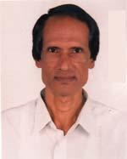 | DR. ABDUR RAZZAQUE  F/Name: Late Md. Ilias Ali  M/Name: Late Mrs. Shafika Khatun  BM & DC Reg. No: 12250  NID:  Cell: 01199329168  Address: C/5 Shamoli Building, Old Medical Colony, Sylhet  Blood Group: O+
185 | Voter No  LM-6500185  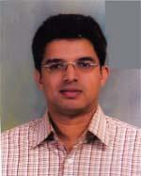 | DR. MD. ZIAUR RAHMAN CHOWDHURY  F/Name: Azizur Rahman Chowdhury  M/Name: Khaleda Aziz Chowdhury  BM & DC Reg. No: 22809  NID: 9196221338316  Cell: 01711469678  Address: Aziza Bag, Nobavun-232, Sonar Para, Shibganj, Sylhet  Blood Group: O+
186 | Voter No  LM-6500186  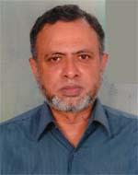 | A. E. MD. ABDUL WASEY  F/Name: Late Md. Abdul Wahab  M/Name: Late Azizunnessa Khatoon  BM & DC Reg. No: 10767  NID: 9196207182179  Cell: 01711887173  Address: 8/3C, Nurani Residential Area (1st Floor), Subidbazar, Sylhet-3100  Blood Group: B+
187 | Voter No  LM-6500187  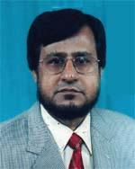 | DR. EMDADUL HUQ MAZUMDER  F/Name: Dr. Anwa Ullah Mazumder  M/Name: Begum Saleha Khatoon  BM & DC Reg. No: 11762  NID: 9196208230883  Cell: 01715172838  Address: Associate Professor (Eye), North East Medical College, Sylhet  Blood Group: B+
188 | Voter No  LM-6500188  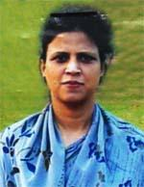 | DR. NAHID ELORA  F/Name: Late Mohammad Mazakkiv  M/Name: Ayesha Khatun  BM & DC Reg. No: 20350  NID: 9196201102120  Cell: 01712664964  Address: 1/A Surma Building, Old Medical Colony, Sylhet  Blood Group: A+
189 | Voter No  LM-6500189 | DR. A Z M MONZURUL HAQUE CHOWDHURY  F/Name: Late Luthful Haque Chowdhury  M/Name:  BM & DC Reg. No:  NID:  Cell:  Address: Jahanarapar Jaharna- 90 Idgah Road .Sylhet.  Blood Group:
190 | Voter No  LM-6500190  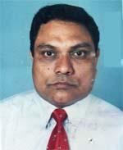 | DR. M. NURUL AFISAR (BADRUL)  F/Name: Al Haj Md. Junab Ali  M/Name: Al Haj Asia Khatun  BM & DC Reg. No: 25477  NID:  Cell: 01711194931  Address: Hamid Khan Villa, 2nd Floor, 23, Nawab Road, Sylhet  Blood Group: B+
191 | Voter No  LM-6500191  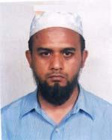 | MD. SOHORAB HOSSAIN BHUIYAN  F/Name: Md. Asheque Ali Bhuiyan  M/Name: Rokeya Sultana  BM & DC Reg. No: 22194  NID: 2694813876691  Cell: 01912706822  Address: Associte Professor, Pathology, Jalalabad Ragib Rabeya Medical College, Sylhet 3100  Blood Group: O+
192 | Voter No  LM-6500192  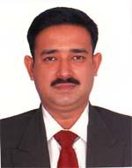 | DR. SYED KHURROM AHMED  F/Name: Late Syed Mohiuddin Ahmed  M/Name: Late Syeda Budrunnesa  BM & DC Reg. No: 32480  NID: 9196211234233  Cell: 01720146977  Address: 60, Kuar Par, Laladigir Par Road, Sadar, Sylhet  Blood Group: O+
193 | Voter No  LM-6500193  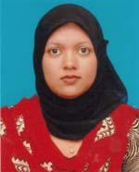 | DR. FAHMINA AKTHER  F/Name: Mohammod Abdul Khalaque  M/Name: Lutfunnesa Khanom  BM & DC Reg. No: 42441  NID: 9196211234234  Cell: 01711357926  Address: 60 Kuar Par, Laladigirpar, Road, Sadar, Sylhet  Blood Group: B+
194 | Voter No  LM-6500194 | DR. MURAD MD. SHAMSHER TABRIS KHAN  F/Name:  M/Name:  BM & DC Reg. No: 47231  NID: 910020120844  Cell: 01711669188  Address: Room No. 116, Shahid Dr. Milon Hostel, Sylhet Mag Osmani Medical College, Sylhet  Blood Group: A+  TRANSFERED to BMA Dhaka City  LM-1405543
195 | Voter No  LM-6500195  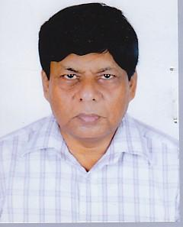 | DR. MD. SHAH JAMAL HOSSAIN  F/Name: Late Mahbubul Hossain  M/Name: Late Zakia Begum  BM & DC Reg. No: 13191  NID:  Cell: 01716015666  Address: A/2, Nice Garden, Nayapara Lane Bazar, Sylhet  Blood Group: O+
196 | Voter No  LM-6500196  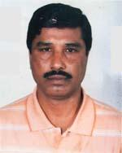 | DR. A. S. M. IMAMUL HOQUE  F/Name: Late M. A. Naser  M/Name: Mst. Aeruza Khatun  BM & DC Reg. No: 29469  NID: 9196216287946  Cell: 01715065354  Address: 42, Tunti Para, Sylhet  Blood Group: B+
197 | Voter No  LM-6500197  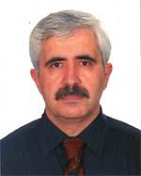 | DR. CYRUS SHAKIBA  F/Name: Late Saadatullah  M/Name: Tabande Khanom  BM & DC Reg. No: 17154  NID:  Cell: 01711345111  Address: 4/2 Boro Bazar, Ambar Khana, Sylhet  Blood Group: B-
198 | Voter No  LM-6500198  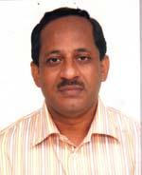 | DR. MD. ABDUS SALAM  F/Name: Md. Sulaiman Ahmed  M/Name: Toymunnesa Khanom  BM & DC Reg. No: 13681  NID: 9196201109511  Cell: 01819650160  Address: UHCFPO, Beanibazar UHC, Post-Beani Bazar, Sylhet  Blood Group: O+
199 | Voter No  LM-6500199  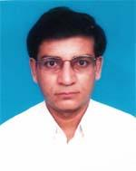 | DR. PARIMAL KUMAR SEN  F/Name: Kanai Lal Sen  M/Name: Josna Rani Sen  BM & DC Reg. No: 26574  NID: 9196211227914  Cell: 01816324545  Address: Medical officer, Dept. of Skin & VD , Sylhet Mag Osmani Medical College Hospital, Sylhet  Blood Group: A+
200 | Voter No  LM-6500200  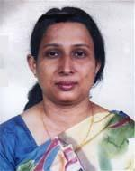 | DR. SHUKLA RANI DAS  F/Name: Gour Sundar Das  M/Name: Bijoya Bala Das  BM & DC Reg. No: 20553  NID: 9196202119383  Cell: 01711859676  Address: Swaraj Bhaban, Meghna B-32, Dariapara, Sylhet  Blood Group: A+
201 | Voter No  LM-6500201 | DR. TANVIR AHMAD CHOUDHURY  F/Name: Late Abdul Matin Choudhury  M/Name: Syeda Saleha Matin  BM & DC Reg. No: 45393  NID: 9196217295614  Cell: 01717132281  Address: Nirjhor, 1st Floor, Ontorongo-53, Kazi Tula, Upper Road, Sylhet-3100  Blood Group: O+
202 | Voter No  LM-6500202  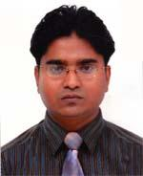 | DR. PRASANTA SARKER  F/Name:  M/Name:  BM & DC Reg. No: 46975  NID: 9196203131304  Cell: 01731247074  Address: Room No. -102, Intern Hostel, SOMCH  Blood Group: O+  TRANSFERED to BMA Dhaka City  LM-1405543
203 | Voter No  LM-6500203  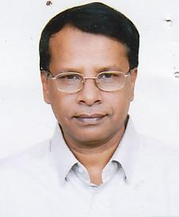 | DR. MD. SADULLAH  F/Name: Late Abu Sayeed  M/Name: Late Salcha Khatun  BM & DC Reg. No: 28865  NID: 9196201108206  Cell: 01711853100  Address: 35 Aurnab, Mirar Moidan, Sylhet  Blood Group: A+
204 | Voter No  LM-6500204 | DR. NAZNEEN JAHAN  F/Name: Mohd. Jahangir  M/Name: Mrs. Nurun Nahar  BM & DC Reg. No: 39300  NID: 9196207167640  Cell: 01717020333  Address: 8, Fazilchist R/a, Subid Bazar, Sylhet  Blood Group: O+
205 | Voter No  LM-6500205  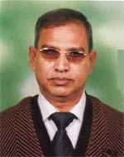 | DR. MD. ABDUL QUDDUS  F/Name: Late Md. Karamat Ali  M/Name: Ms. Nejura Khatun  BM & DC Reg. No: 11138  NID: 910007102363  Cell: 01715294592  Address: Jalalabad Ragib Rabeya Medical College, Sylhet  Blood Group: A+
206 | Voter No  LM-6500206  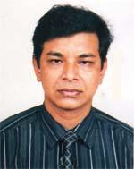 | DR. HRITU RAJ DEB  F/Name: Radhika Ranjan Deb  M/Name: Gita Rani Deb  BM & DC Reg. No: 29214  NID:  Cell: 01712219004  Address: Srijoni, 31, Vathalia, Sylhet  Blood Group: AB+
207 | Voter No  LM-6500207  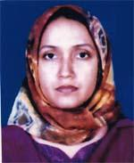 | DR. KANIZ FATEMA CHOWDHURY  F/Name: Shatat Ahmed Chowdhury  M/Name: Shamsun Nahar Chowdhury  BM & DC Reg. No: 31506  NID:  Cell: 01716800842  Address: Vill-Yusuf Sadar, Post-Prittim Pashl, Kulaura, Moulvi Bazar  Blood Group: O+
208 | Voter No  LM-6500208  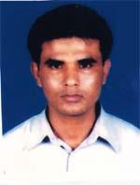 | DR. MD. MOSHARUL HAQUE  F/Name: Md. Abdul Mazid  M/Name: Mrs. Sharifa Begum  BM & DC Reg. No: 31507  NID:  Cell: 01716800842  Address: Vill-Mothergonj, Post-Kachuari, P.s & Dist-Thakurgaon  Blood Group: O+
209 | Voter No  LM-6500209  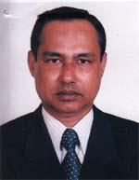 | DR. DIPENDRA NARAYAN DAS  F/Name: Late Romeudra Narayan Das  M/Name: Late Putul Bala Das  BM & DC Reg. No: 17800  NID:  Cell: 01711447817  Address: Nibash C/42, Moyna Monzil, Modina Market, West Pathantula, Sylhet  Blood Group: B+
210 | Voter No  LM-6500210  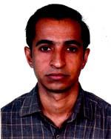 | DR. MD. TAWHIDUL ISLAM IMDAD  F/Name: Md. Sirajul Islam  M/Name: Ashabunnesa Khatun  BM & DC Reg. No: 29625  NID: 9196208192618  Cell: 01711013263  Address: Skin VD dept. , Jalalabad Ragib Rabeya Medical College Hospital, Sylhet-3100  Blood Group: O+
211 | Voter No  LM-6500211  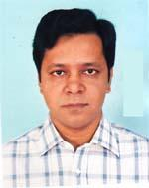 | DR. SHANKAR KUMAR ROY  F/Name: Ananta Roy  M/Name: Sumila Roy  BM & DC Reg. No: 25920  NID: 9196201102453  Cell: 01711608318  Address: 5/F, Old Medical Colony, Sylhet Medical College Hospital, Sylhet  Blood Group: B+
212 | Voter No  LM-6500212  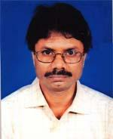 | DR. PROBHAT RANJAN DEY  F/Name: Late Mohendra Kumar Dey  M/Name: Projulla Bala Dey  BM & DC Reg. No: 15242  NID: 9196211229747  Cell: 01711190604  Address: Assistant Professor, Wept of Paediatric, Mag Osmani Medical College, Sylhet  Blood Group: A+
213 | Voter No  LM-6500213  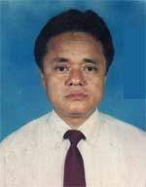 | DR. PROMODE RANJAN SINGH  F/Name: Late Tanjaw Singh  M/Name: Late Parijat Devi  BM & DC Reg. No: 11071  NID: 9196220332200  Cell: 01711848879  Address: 67/A, Alpona, shibgonj, Sylhet  Blood Group: B+
214 | Voter No  LM-6500214  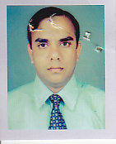 | DR. SADHU UTTAM KUMAR  F/Name: Babu Kali Pada Sadhu  M/Name:  BM & DC Reg. No:  NID:  Cell:  Address: 151 Surma Valley Topkhana Sylhet.  Blood Group:
215 | Voter No  LM-6500215  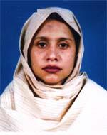 | DR. SHAH FAHMIDA SIDDIQUA  F/Name: Dr. Late M. Ahmed Hossain  M/Name: Mrs. Rehana Hossain  BM & DC Reg. No: 28758  NID: 9196201102376  Cell: 01711833944  Address: 2/C Urmee, Building , Old Medical Colony, Stadium, Sylhet  Blood Group: O+
216 | Voter No  LM-6500216  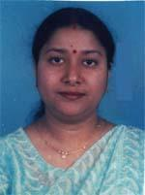 | DR. KABERI DAS GUPTA  F/Name: Ajit Ranjan Das Gupta  M/Name: Smriti Das Gupta  BM & DC Reg. No: 28684  NID:  Cell: 01711114250  Address: 48, Prantik, Mia Fazil Chist, Sylhet  Blood Group: B+
217 | Voter No  LM-6500217  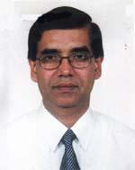 | DR. DIPANKAR NATH TALUKDER  F/Name: Atul Chandra Nath Talukder  M/Name: Nani Bala Debi  BM & DC Reg. No: 15068  NID: 91962002119382  Cell: 01711859677  Address: Swaraj Bhaban, Meghna B-32, Daria Para, Sylhet-3100  Blood Group: B+
218 | Voter No  LM-6500218  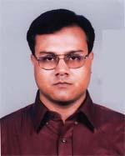 | DR. MD. SHAMSUR RAHMAN  F/Name: Dr. Md. Abdul Qayyum  M/Name: Late Mrs. Khaisun Nessa  BM & DC Reg. No: 23451  NID: 9196201102129  Cell: 01711829151  Address: 6/C, Barnali, Old Medical Colony, Rikabibazar, Sylhet  Blood Group: A+
219 | Voter No  LM-6500219  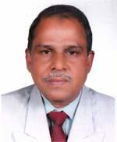 | DR. A. K. M. ZILLUL HAQUE  F/Name: Late Md. Haris  M/Name: Late Joriful Nessa  BM & DC Reg. No: 11143  NID: 9196207168061  Cell: 01712297303  Address: Jumir Consultant, Anaesthesiology Sylhet M.a.g. Osmani Medical College Hospital  Blood Group: A+
220 | Voter No  LM-6500220  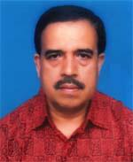 | DR. TRIDIV CHOWDHURY  F/Name: Nirmalendu Chowdhury  M/Name: Jyoti Rani Chowdhury  BM & DC Reg. No: 15913  NID:  Cell: 01711114250  Address: 48, Prantik, Mia Fazil Chist, Sylhet  Blood Group: A+
221 | Voter No  LM-6500221  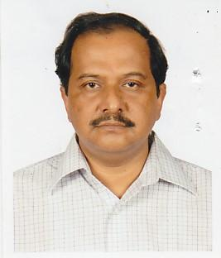 | DR. MUHAMMAD SHAHABUDDIN  F/Name: Md. Moslem Alom  M/Name: Late Rahima Begum  BM & DC Reg. No: 15422  NID: 38476  Cell: 01715067019  Address: Assist. Prof. Cardiology . Sylhet Mag Osmani Medical College  Blood Group: A+
222 | Voter No  LM-6500222  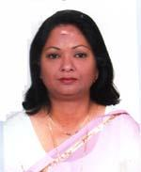 | DR. YASMIN SHAMMI AHMED  F/Name: Late Siraj Uddin Ahmed  M/Name: Dr. Mamtaz Begum  BM & DC Reg. No: 17410  NID: 9196201108209  Cell: 01715044682  Address: 35, Arnab, Mirer Moidan, Sylhet  Blood Group: A+
223 | Voter No  LM-6500223 | DR. MD. HARUNUR RASHID  F/Name: Late Md. Jafor Miah  M/Name: Mrs. Rashida Jafor  BM & DC Reg. No: 25935  NID: 9196207167831  Cell: 01711138204  Address: 13, Fazil Chist, Subid Bazar, Sylhet  Blood Group: O+
224 | Voter No  LM-6500224  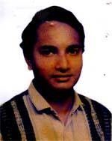 | DR. ALAMGIR AHMED CHOWDHURY  F/Name: Late Abul Fazal Chowdhury  M/Name: Mrs. Saleha Chowdhury  BM & DC Reg. No: 30486  NID: 9196201107854  Cell: 01819652900  Address: 105, Paira, Dorgamoholla, Sylhet  Blood Group: B+
225 | Voter No  LM-6500225  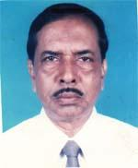 | DR. SHAJIBUR RAHMAN  F/Name: Late Hazi Md. Iasir Ali  M/Name: Late Mt. Abeda Bibi  BM & DC Reg. No: 7104  NID: 9113869900802  Cell: 01714912721  Address: Assit. Director Medical Sub, Depo Khulna Resident, Hospital Quarter B. Bazar, Sylhet  Blood Group: O+
226 | Voter No  LM-6500226  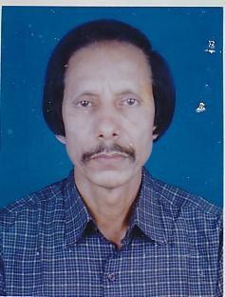 | DR. HARIS UDDIN AHMED  F/Name: Md. Sadat Ali  M/Name: Ms. Michiljan  BM & DC Reg. No: 9098  NID:  Cell: 01712574263  Address: Upazilla Health Complex, Jaintapur, Sylhet  Blood Group: B+
227 | Voter No  LM-6500227  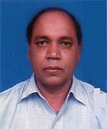 | DR. MD. NAZRUL ISLAM BHUIYAN  F/Name: Late Md. Abdus Sattar Bhuiyan  M/Name: Umme Kulsum Khanom  BM & DC Reg. No: 13467  NID: 9196201102403  Cell: 01711340933  Address: Assistant Professor, Pathology, Sylhet Womens Medical College  Blood Group: O+
228 | Voter No  LM-6500228  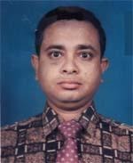 | DR. PANKAJ PAUL  F/Name: Babul Paul  M/Name: Bina Pani Paul  BM & DC Reg. No: 21363  NID: 9110840751420  Cell: 01711984069  Address: 12/2 Alpona, Aditya Para, Shibgonj, Sylhet  Blood Group: O+
229 | Voter No  LM-6500229  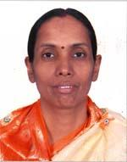 | DR. MADHABI RANI DEB  F/Name: Late Bikash Ranjan Deb  M/Name: Mrs. Malati Rani Deb  BM & DC Reg. No: 14853  NID:  Cell: n/a  Address: 38, Swapnil Ramerdisirpar, Mirzasajal, Sylhet-3100  Blood Group: n_a
230 | Voter No  LM-6500230  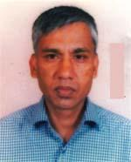 | DR. MD. MOSHAROF HOSSAIN  F/Name: Late Md. Muradullaman  M/Name: Mrs. Jamila Khatun  BM & DC Reg. No: 11786  NID: 9196201102101  Cell: 01711301173  Address: Kakoli 4D, Old Medical Colony, Sylhet Mag Osmani Medical College  Blood Group: B+
231 | Voter No  LM-6500231  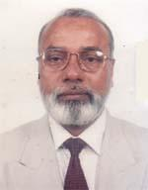 | DR. MOHAMMAD ABDUL WAHID  F/Name: Late Md. Ajam Ullah  M/Name: Late Joygun Bibi  BM & DC Reg. No: 6887  NID: 9196222352343  Cell: 01711360809  Address: House No. 14, Road No. 30, Shahjalal Upo Shahaor, Sylhet  Blood Group: O+
232 | Voter No  LM-6500232  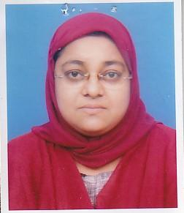 | DR. RUKHSHANA JAHAN  F/Name: Late A.z.m Rafiqul Hussain  M/Name: Syeda Rabeya Begum  BM & DC Reg. No: 23139  NID: 9196203124628  Cell: 01711317479  Address: 116, Kajal shah R/A, Sylhet  Blood Group: O+
233 | Voter No  LM-6500233  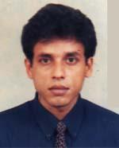 | DR. DHRUBAJYOTI ROY CHOWDHURY  F/Name: Dhirendra Chandra Roy Chowdhury  M/Name: Supriti Roy Chowdhury  BM & DC Reg. No: 34734  NID: 3612613846827  Cell: 01711385469  Address: 44, Paira, Dargamahalla, Sylhet  Blood Group: O+
234 | Voter No  LM-6500234  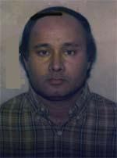 | DR. GOPIKESH RANJAN DEY  F/Name: Late Gopendra Dey  M/Name: Late Pratua Dey  BM & DC Reg. No: 17474  NID: 9196213249271  Cell: 01712242959  Address: House No. 6, Aliview, Taltala, Sylhet  Blood Group: AB+
235 | Voter No  LM-6500235  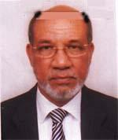 | PROF. DR. MEER MAHBUBUL ALAM  F/Name: Meer Golam Mostafa  M/Name: Mazeda Khatun  BM & DC Reg. No: 6958  NID: 9196203120788  Cell: 01711331468  Address: Professor & Surgery, Sylhet Mag Osmani Medical College , Sylhet  Blood Group: A+
236 | Voter No  LM-6500236  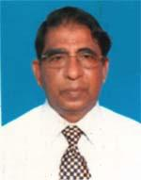 | DR. RUKNUL AZIZ CHOWDHURY  F/Name: Md. Ismail Chowdhury  M/Name: Kulsuma Khatun Chowdhury  BM & DC Reg. No: 8545  NID: 9196217297860  Cell: 01199320755  Address: Sineor Store Officer, Mag Osmani Medical College Hospital  Blood Group: O+
237 | Voter No  LM-6500237  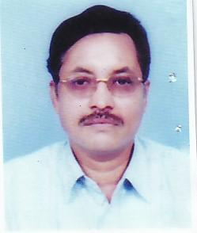 | DR. SYED SHAFI AHMED MUAZ  F/Name: Late Syed Abdul Hamid  M/Name: Kazi Manwara Begum  BM & DC Reg. No: 18052  NID:  Cell: 01711144371  Address: Associate Professor of Paediatrics Jalalabad Ragib Rabeya Medical College, Sylhet  Blood Group: B+
238 | Voter No  LM-6500238  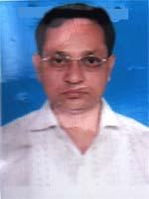 | DR. BIDHAN CHANDRA DEBNATH  F/Name: Kshetra Mohan Debnath (late)  M/Name: Renu Bala Debi  BM & DC Reg. No: 13313  NID: 9196203122107  Cell: 01715151604  Address: 6/A, Kajalshah, Sylhet, Lecturer, Biochemistry, Osmani Medical College , Sylhet  Blood Group: B+
239 | Voter No  LM-6500239 | DR. DEWAN ALI HASSAN CHOWDHURY  F/Name: Dewan Ali Azam Chowdhury  M/Name: Saleha Khatun  BM & DC Reg. No: 18124  NID: 9196201102324  Cell: 01711349091  Address: Building No. 1, Flat -D, Old Medical Colony, Sylhet-3100  Blood Group: B+
240 | Voter No  LM-6500240  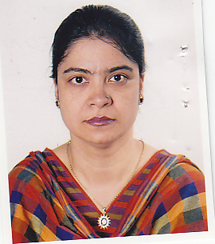 | DR. SAKHINA KHATUN  F/Name: Siraj Uddin Chowdhury  M/Name:  BM & DC Reg. No:  NID:  Cell:  Address: Building No 1 Flat-D Old Medical Colony Sylhet.  Blood Group:
241 | Voter No  LM-6500241  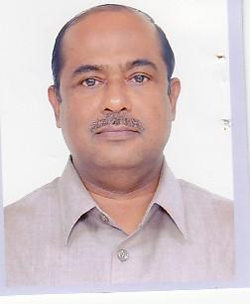 | DR. SUDHENDU BIKASH DAS  F/Name: Late Naresh Chandra Das  M/Name: Mrs. Simantini Das  BM & DC Reg. No: 13418  NID:  Cell: 01711484904  Address: 38, Swapnil, Ramerdigirpar, Mirzajangal, Sylhet-3100  Blood Group: O+
242 | Voter No  LM-6500242  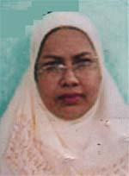 | DR. HOMAIRA BEGUM  F/Name: Muhammad Abdul Quder  M/Name: Jahan Ara Begum  BM & DC Reg. No: 17220  NID: 9196211229121  Cell: 01715250164  Address: 138/1, Tamima Apartment, Nawab Road, Kazal Shah , Sylhet-3100  Blood Group: B+
243 | Voter No  LM-6500243  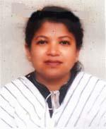 | DR. SHAMIM AKHTER MIMI  F/Name: Shamsul Hoque  M/Name: Gul-e-anar  BM & DC Reg. No: 22839  NID: 9196212244358  Cell: 01819580474  Address: 358, Shuvescha, Shiekghat, Sylhet  Blood Group: O+
244 | Voter No  LM-6500244 | DR. KHONDAKER SERAJUDDIN  F/Name: Salehuddin Khondaker  M/Name: Fatema Akhter Khatun  BM & DC Reg. No: 14979  NID: 9196211229120  Cell: 01751778351  Address: 138/1, Tamima Apartment Nawab Road, Kazalshah, Sylhet-3100  Blood Group: A+
245 | Voter No  LM-6500245  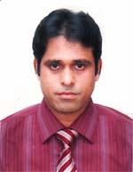 | DR. A. N. M. NURUL HUDA NAYEEM  F/Name: Late Md. Abdul Latif  M/Name: Begum Noor Jahan  BM & DC Reg. No: 31660  NID: 9196203123115  Cell: 01711156807  Address: 96, Kajol Shah, New Medical Road, Sylhet  Blood Group: O+
246 | Voter No  LM-6500246  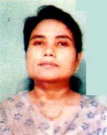 | DR. SANCHITA RANI SINHA  F/Name: Joy Mohon Singha  M/Name: Aroti Sinha  BM & DC Reg. No: 21706  NID: 9110840751421  Cell: 01711580366  Address: 12/2 Alpona, Aditya para, Shibgonj, Sylhet  Blood Group: A+
247 | Voter No  LM-6500247  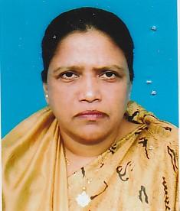 | DR. HUSNE ARA BEGUM  F/Name: Late Dr. Md. Musharaf Ali  M/Name: Late Nurjahan Begum  BM & DC Reg. No: 3615  NID:  Cell: n/a  Address: Old Medical Colony, Sylhet  Blood Group: B+
248 | Voter No  LM-6500248  No Image | DR. ZULFIQUAR AHMED JAMI  F/Name: Late Siraj Uddin Ahmed  M/Name: Dr. Momtaz Begum  BM & DC Reg. No: 27979  NID: 9196203123915  Cell: 01715140816  Address: Poroshi 201, Kewapara, Sylhet  Blood Group: A+
249 | Voter No  LM-6500249  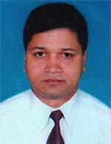 | DR. SHISHIR R. CHAKRABORTY  F/Name: Late Satyendra Kumar Chakraborty  M/Name: Pankajini Chakraborty  BM & DC Reg. No: 23483  NID: 9196211231027  Cell: 01715274811  Address: Flat No 07, Nice Garden, Bithika A/L, Lamaoazar, Sylhet  Blood Group: B+
250 | Voter No  LM-6500250 | DR. SHISHIR KUMAR BASAK  F/Name: Gopal Chandra Basak  M/Name: Reba Rani Basak  BM & DC Reg. No: 19437  NID: 9196211236563  Cell: 01711854921  Address: 138/1, Nabab Road, Kajolshah, Sylhet  Blood Group: O+
251 | Voter No  LM-6500251  No Image | DR. MD. ABDUL BARI  F/Name:  M/Name:  BM & DC Reg. No:  NID:  Cell:  Address:  Blood Group:  TRANSFERED to BMA Dhaka City  LM-1405543
252 | Voter No  LM-6500252  No Image | DR. GOUTAM KUMAR ROY  F/Name: Gopendra Lal Roy.  M/Name:  BM & DC Reg. No:  NID:  Cell:  Address: Professor Of Medicine Jalalabat Rajib Rabeya Medical College Sylhet.  Blood Group:
253 | Voter No  LM-6500253  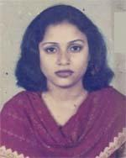 | DR. ANUPOMA RAHMAN  F/Name: Topan Kanti Dhar  M/Name: Amita Dhar  BM & DC Reg. No: 34415  NID: 9196207175431  Cell: 01711700798  Address: Doctors Resident Chowhatfa, Sylhet  Blood Group: A+
254 | Voter No  LM-6500254  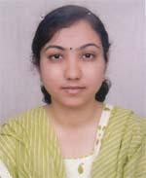 | DR. TANZILA FARHANA  F/Name: Rukon Uddin Ahmed  M/Name: Salina Begum  BM & DC Reg. No: 53621  NID: 9196203129298  Cell: 01720146085  Address: 10, Munshipara, Sylhet  Blood Group: O+
255 | Voter No  LM-6500255 | DR. SHAHRIAR AHMAD KHALIL CHOWDHURY  F/Name: Raziur Rahman Chowdhury  M/Name: Shamsunnesa Chowdhury  BM & DC Reg. No: 23234  NID:  Cell: 01819657528  Address: House No. F, Building No. 7, Old Medecal Colony, Rekabibazar, Sylhet  Blood Group: A-
256 | Voter No  LM-6500256  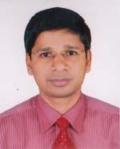 | DR. RANJON KUMER ROY  F/Name: Late Vogoban Chawdro Roy  M/Name: Banu Bala Roy  BM & DC Reg. No: 28379  NID: 9196208189450  Cell: 01711288814  Address: Medicine Outdoor, SOMCH  Blood Group: O+
257 | Voter No  LM-6500257  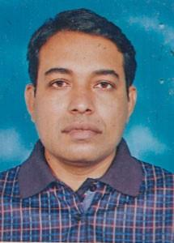 | DR. BABLU KUMAR SARKAR  F/Name: Late Harendra Nath Sarkar  M/Name: Late Moyna Rani Sarkar  BM & DC Reg. No: 44152  NID: 9110840751447  Cell: 01717021050  Address: Murad Medical Cornar, Hazi Nasib Ullah Market, Goalabazar, Sylhet  Blood Group: B+
258 | Voter No  LM-6500258  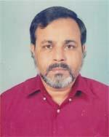 | DR. M. S. RAHMAN  F/Name: Late Md. Abdur Rahman  M/Name: Late Yeakuti Begum  BM & DC Reg. No: 7023  NID: 19559196209197119  Cell: 01715195553  Address: Renesa 33, Block R-B, Road-3, Sorma R/A, Akhaya, Sylhet  Blood Group: B+
259 | Voter No  LM-6500259  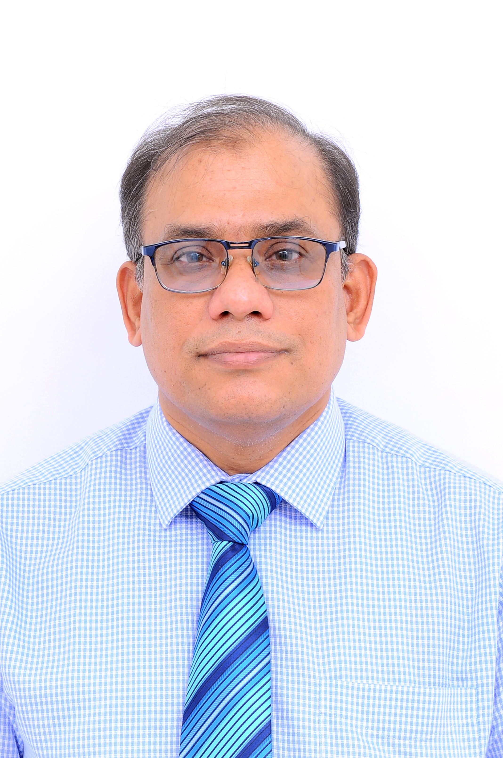 | DR. MUJIBUL HOQUE  F/Name: Late Abdul Latif  M/Name: Mrs. Beena Latif  BM & DC Reg. No: 27309  NID: 9196211236084  Cell: 01911132026  Address: Department of Paediatrics, Mag Osmani Medical College & Hospital, Sylhet  Blood Group: B+
260 | Voter No  LM-6500260  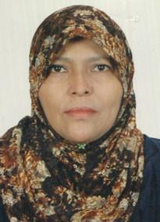 | DR. NADIRA BEGUM  F/Name: Late Abdul Wazed  M/Name: Jahanara Begum  BM & DC Reg. No: 14942  NID: 9196209204894  Cell: 01711347539  Address: Flat No. H, 4th Floor, Parijal Bhaban Dorgamohallah, Sylhet  Blood Group: O+
261 | Voter No  LM-6500261  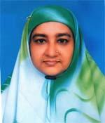 | DR. RASHIDA AKHTER  F/Name: Md. Anisur Rahman  M/Name: Mrs. Jebun Nessa  BM & DC Reg. No: 19047  NID: 9196211234562  Cell: 01711829744  Address: Kamar Nibash, Nobabrd, Kazalshal, Sylhet  Blood Group: A+
262 | Voter No  LM-6500262  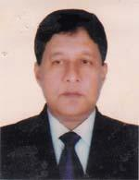 | DR. MD. TAIFUR RAHIM  F/Name: Zahidur Rahim  M/Name: Mrs. Amena Khatoon  BM & DC Reg. No: 10763  NID:  Cell: 01711921845  Address: 44, Chaya Tour, Sheikhpara (Kaupar), Sylhet 3100  Blood Group: A+
263 | Voter No  LM-6500263 | DR. MD. ABDUL LATIF  F/Name: Akher Ali Sheikh  M/Name: Mosirun Nesa  BM & DC Reg. No: 16584  NID: 9196201108916  Cell: 01713300356  Address: 2/D, Urmi, Old Medical Colony, Sylhet  Blood Group: O+
264 | Voter No  LM-6500264 | DR. MD. ARIFUL HAQUE CHOWDHURY  F/Name: M.a. Mokthodir Chowdhury  M/Name: Fahmida Chowdhury  BM & DC Reg. No: 54810  NID: 9196201109500  Cell: 01712853111  Address: House no. 81, Bilpar, Lamabazar, Sylhet  Blood Group: A+
265 | Voter No  LM-6500265 | DR. HIMANGSHU SHEKAR DAS  F/Name: Iresh Lal Das  M/Name: Biva Rani Das  BM & DC Reg. No: 39017  NID: 9196213248649  Cell: 01711366189  Address: Shopnil -22, Ramer Dighir Das, Sylhet  Blood Group: B+
266 | Voter No  LM-6500266 | DR. GOLAM MD. MOIN UDDIN  F/Name: Shaleh Uddin Ahmed  M/Name: Ismat Ara  BM & DC Reg. No: 54529  NID: 9196213253063  Cell: 01717415337  Address: Saifam Kutir 53, Aparupa Mohonpur R/a, Habiganj  Blood Group: B+
267 | Voter No  LM-6500267  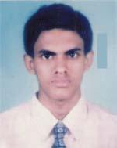 | DR. DIPONGKAR ROY  F/Name: Pradip Ranjan Roy  M/Name: Jayanti Roy  BM & DC Reg. No: 57415  NID:  Cell: 01717189223  Address: Bandhan 284, Gopinathpur, Chirkandi, Habiganj  Blood Group: O+
268 | Voter No  LM-6500268  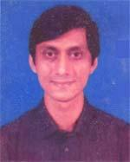 | DR. MD. SALEH AHMED  F/Name: Md. Mahbubur Rahman  M/Name: Ashra Funnesa Khatoon  BM & DC Reg. No: 23186  NID:  Cell: 01712846131  Address: H-10, R-2, Uposhohor, Sylhet  Blood Group: AB+
269 | Voter No  LM-6500269  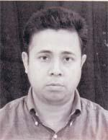 | DR. MD. ENAYET HOSSAIN  F/Name: Md. Abul Kamal Mollah  M/Name: Mrs. Rokeya Begum  BM & DC Reg. No: 28891  NID: 9116295475487  Cell: 01711198194  Address: A1/5, Professors Quarter, sylhet Agricultural University Tilagore, sylhet  Blood Group: AB+
270 | Voter No  LM-6500270  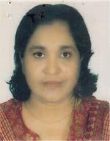 | DR. JAMILA KHATUN  F/Name: Md. Surat Jamal  M/Name: Mrs. Rawshan Ara Begum  BM & DC Reg. No: 22587  NID:  Cell: 01712618242  Address: Porshi 101, Mirar Moidan, Sylhet  Blood Group: A+
271 | Voter No  LM-6500271  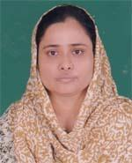 | DR. NASIMA AKTHER  F/Name: Late Md. Monir Uddin  M/Name: Mrs. Rezia Begum  BM & DC Reg. No: 3204  NID: 19742690243835808  Cell: 01712178390  Address: Gurni-3/A, Ground Floor Old Medical Colony, Sylhet  Blood Group: B+
272 | Voter No  LM-6500272  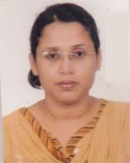 | DR. MUSS. FATEMA YEASMIN  F/Name: Md. Ismail Hossain  M/Name: Khudeza Khanom  BM & DC Reg. No: 41348  NID: 9196203129220  Cell: 01712156954  Address: Goala Bazar Uhc Fwc, Balagang, Sylhet  Blood Group: O+
273 | Voter No  LM-6500273  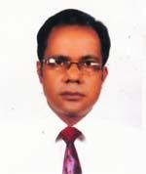 | DR. PARTHA SARATHI DE  F/Name: Late Dr. Upendra Chandra De  M/Name: Mrs. Dipti Rani De  BM & DC Reg. No: 45198  NID: 9110840751231  Cell: 01715068136  Address: Rubel Pharmacy, Goala Bazar, Osmaninagar, Sylhet  Blood Group: O+
274 | Voter No  LM-6500274  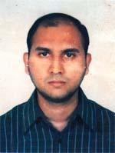 | DR. RAZWAN FERDOUS  F/Name: Late Jamal Ahmed  M/Name: Shamima Begom  BM & DC Reg. No: 49049  NID: 9196209203906  Cell: 01717742064  Address: Lutfa Monjil, 63, Shagordigir Par, Sylhet  Blood Group: A+
275 | Voter No  LM-6500275 | DR. ABU NOYEEM MD. YOUSUF  F/Name: Md. Abu Taher  M/Name: Rawsan Ara Begum (late)  BM & DC Reg. No: 32893  NID: 9196201102406  Cell: 01711361150  Address: 4/E Old Medical Colony, Rikabi Bazar , Sylhet  Blood Group: AB+
276 | Voter No  LM-6500276  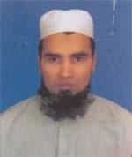 | DR. MUHAMMAD OLIUR RAHMAN  F/Name: Muhammad Abdul Fattah  M/Name: Umme Salma  BM & DC Reg. No: 35910  NID: 9196201102253  Cell: 01715242759  Address: Mitali-7/A, Old Medical Colony, Sylhet  Blood Group: A+
277 | Voter No  LM-6500277 | DR. MASUM AHMED  F/Name: Mohammed Furkan Ali  M/Name: Mrs. Joynur Nahar  BM & DC Reg. No: 40742  NID: 9121706663259  Cell: 01712211303  Address: Vill-Fothepur, Post-Beani Bazar, Sylhet  Blood Group: O+
278 | Voter No  LM-6500278  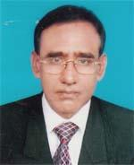 | DR. SYED SHAHIDUL ISLAM  F/Name: Late Syed Aftab Ali  M/Name: Late Syeda Razia Khatoon  BM & DC Reg. No: 8345  NID: 9196207182186  Cell: 01711194880  Address: 10/1, Noorani Subid Bazar, Sylhet  Blood Group: A+
279 | Voter No  LM-6500279  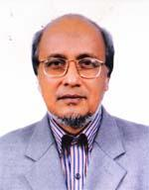 | DR. KAZI MD. SALIM  F/Name: Kazi Arefur Rahman (late)  M/Name: Kazi Rashida Khatun (late)  BM & DC Reg. No: 9093  NID: 9196211234563  Cell: 01711311722  Address: Kamar Nibash, Nabab Road, Kajal Shah, Sylhet-3100  Blood Group: O+
280 | Voter No  LM-6500280  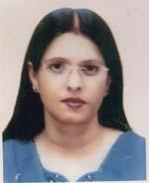 | DR. SUPRAVA DAS  F/Name: Dr. Satish Chandra Das  M/Name: Mrs. Sudebi Bala Das  BM & DC Reg. No: 33979  NID: 9196201109347  Cell: 01711364228  Address: 156, suvechcha, Mia Fazil Chist, Sylhet  Blood Group: O+
281 | Voter No  LM-6500281 | MD. OLIUR RAHMAN CHOWDHURY  F/Name: Md. Hafizur Rahman Chowdhury  M/Name: Sultana Begum  BM & DC Reg. No: 54532  NID: 9116242569441  Cell: 01712885347  Address: Fazlur Rahman Manson, Shaparan Gate, Khadim Nagar, Sylhet  Blood Group: O+
282 | Voter No  LM-6500282  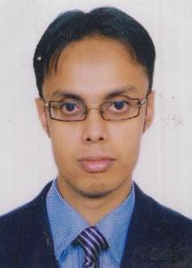 | DR. SHAFIUL ALAM FAZALUR RAHMAN  F/Name: Fazlur Rahman  M/Name: Mosammat Hajera Begum  BM & DC Reg. No: 54061  NID: 9196217299411  Cell: 01732094433  Address: Al Hafiz Villa, Block C-m/9, Kumar para, Sylhet Sadar, Sylhet-3100  Blood Group: AB+
283 | Voter No  LM-6500283  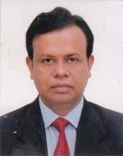 | DR. MD. MUKHLASUR RAHMAN  F/Name: Abdur Razzak  M/Name: Ayesha Khatun  BM & DC Reg. No: 21355  NID: 9196203127726  Cell: 01712079393  Address: 45, shagordigir Par, Sobid Bazar, Sylhet  Blood Group: A+
284 | Voter No  LM-6500284  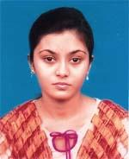 | DR. SMITA DAS  F/Name: Dr. Mohitosh Ranjan Das  M/Name: Dr. Dipti Rani Saha  BM & DC Reg. No: 53526  NID: 9196212244916  Cell: 01710212092  Address: 34/1, Nabin, Bhangatikor para, Sylhet  Blood Group: B+
285 | Voter No  LM-6500285  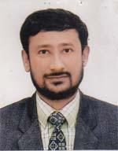 | DR. JAHIR UDDIN MOHAMMAD  F/Name: Late Md. Abdur Rashid  M/Name: Jubaida Katun  BM & DC Reg. No: 7531  NID: 9196211229242  Cell: 01558354683  Address: Flat No. F, Exel Tower, 10th Floor, Subid Bazar, Sylhet  Blood Group: B+
286 | Voter No  LM-6500286  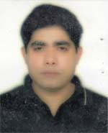 | DR. SUSHIL KUMAR SINGNA  F/Name: Late Bani Madhab Singha  M/Name: Purnima Debi  BM & DC Reg. No: 36212  NID: 9123805980830  Cell: 01712194486  Address: Medical officer, Sylhet Gas Fields Lotd, Koilastila, Golapgonj, Sylhet  Blood Group: A+
287 | Voter No  LM-6500287  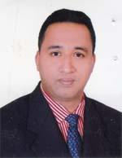 | DR. MD. SHAHINUR ISLAM  F/Name: Md. Abul Hussain  M/Name: Mrs. Shaleha Begum  BM & DC Reg. No: 42825  NID: 9123805987662  Cell: 01712722454  Address: Golapgonj Bazar, Main Road, Golapgonj, Sylhet  Blood Group: O+
288 | Voter No  LM-6500288  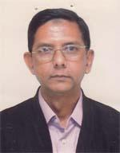 | DR. MD. MOQBUL HUSSAIN  F/Name: Late Alhaj Md. Abul Hussain  M/Name: Asia Khatun  BM & DC Reg. No: 14590  NID: 9196204136009  Cell: 01552421880  Address: 73, Provati, Peermoholla, Mozumdari, Sylhet  Blood Group: A+
289 | Voter No  LM-6500289 | DR. NANDITA PAUL  F/Name: Nitya Gopal Paul  M/Name: Swapna Paul  BM & DC Reg. No: 40562  NID: 2696653265089  Cell: 01766220779  Address: 89-Azadi, Mirboxtula, Sylhet  Blood Group: B+
290 | Voter No  LM-6500290  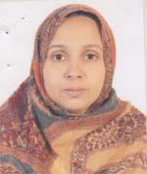 | DR. MOMTAZ BEGUM  F/Name: Md. Abdul Quadir  M/Name: Maliquennessa Khatun  BM & DC Reg. No: 30536  NID: 9196208195694  Cell: 01716526575  Address: 16/a, Mohona, Pathautala, Sylhet  Blood Group: A+
291 | Voter No  LM-6500291  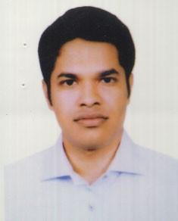 | DR. MD. ADNAN CHOWDHURY  F/Name: Md. Moseh Uddin Chowdhury  M/Name: Shamsun Nahar Begum  BM & DC Reg. No: 57663  NID: 9196201102124  Cell: 01722501525  Address: 1/B, Old Medical Colony, Sylhet  Blood Group: AB+
292 | Voter No  LM-6500292  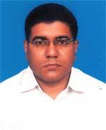 | DR. SIDDHARTHA PAUL  F/Name: Prof. Dr. N. K. Paul  M/Name: Rina Paul  BM & DC Reg. No: 30270  NID: 9196209197100  Cell: 01712280547  Address: 89 Azadi, Mirboxtula, Sylhet  Blood Group: O+
293 | Voter No  LM-6500293 | DR. BIJIT CHANDRA DAS  F/Name: Late Barindra Chandra Das  M/Name: Late Protiva Rani Das  BM & DC Reg. No: 23027  NID: 9123801973137  Cell: 01715484258  Address: Kodomtali , Phul Bari Purba Para, Golap Gonj Bazar, Golapgonj, Sylhet  Blood Group: O+
294 | Voter No  LM-6500294  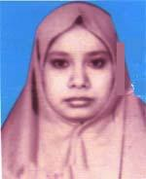 | DR. FARZANA SULTANA  F/Name: A.b.m. Abul Khair  M/Name: Hosne Ara Begum  BM & DC Reg. No: 33877  NID: 2697690519543  Cell: 01674088620  Address: Kulaura Poly Clinic, Mam Centre Usla Para, Kolaura, Moulvibazar  Blood Group: O+
295 | Voter No  LM-6500295  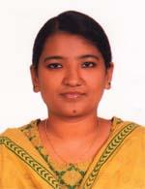 | DR. SHARMILA KARMAKER  F/Name: Dr. Basudev Karmaker  M/Name: Ava Karmaker  BM & DC Reg. No: 54084  NID: 9113825873479  Cell: 01717674384  Address: Post-Dhakadakshir (Mirrapara), Vill-Daharail, P.s-Golapgonj, Dist-Sylhet  Blood Group: O-
296 | Voter No  LM-6500296  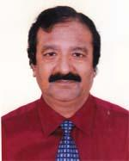 | DR. BASUDEV KARMAKER  F/Name: Late Mahendra Karmaker  M/Name: Late Parul Karmaker  BM & DC Reg. No: 8250  NID: 19539113825873477  Cell: 01711140826  Address: Post-Dhakadakshin (misrapara), Vill-Daharail, Dist-Sylhet, P.s-Golapgonj  Blood Group: B+
297 | Voter No  LM-6500297  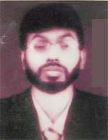 | DR. MOHAMMAD BAREK MOLLAH  F/Name: Abdur Rouf Mollah  M/Name: Zobeda Khatun  BM & DC Reg. No: 36699  NID: 2697690519542  Cell: 01711030989  Address: Kulaura Poly Clinic, Mam Centre, Uslapar, Kulaura, Moulvibazar  Blood Group: O+
298 | Voter No  LM-6500298  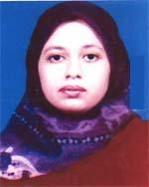 | DR. CHOUFHURY RIFAT JAHAN  F/Name: Dr. C. M. Noor Ahmed  M/Name: Dr. Z. S. Mansura Khatun  BM & DC Reg. No: 47495  NID: 9196204137748  Cell: 01712509876  Address: 122, Housing Estate, Amberkhana, Sylhet  Blood Group: AB+
299 | Voter No  LM-6500299 | DR. MD. FAIZ ULLAH (FAHIM)  F/Name: Salamat Ullah  M/Name: Raisa Khatun  BM & DC Reg. No: 46790  NID: 5816553527871  Cell: 01715614712  Address: PMO (Chicf Executive Manager), Muslim Aid, Hospital, Brahmanbazar, Kulaura, Moulvibazar  Blood Group: AB+
300 | Voter No  LM-6500300  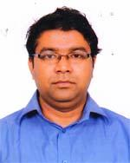 | DR. MOHAMMED REZAUL KABIR  F/Name: Mohammed Farid Ahmed  M/Name: Shah Shamima Farid  BM & DC Reg. No: 50470  NID: 9196213250306  Cell: 01716023400  Address: 62 Nilima R/a, Khulia Para, Sheikh Ghat, Sylhet  Blood Group: B+
301 | Voter No  LM-6500301  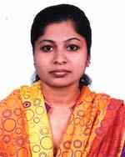 | DR. DIPANNITA GOPE  F/Name: Mati Lal Gope  M/Name: Arati Purkayastha  BM & DC Reg. No: 50320  NID: 9196221339720  Cell: 01718107166  Address: House No. 14, Road No. 2, Hatimbug R/A Shibgonj, Sylhet  Blood Group: O+
302 | Voter No  LM-6500302  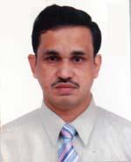 | DR. MOHD. ABDUS SAMAD AZAD  F/Name: Md. Abdus Shahid  M/Name: Lutfa Begum  BM & DC Reg. No: 22696  NID:  Cell: 01711389260  Address: Focus -303, Block-B, North Baluchor, Sylhet  Blood Group: B+
303 | Voter No  LM-6500303  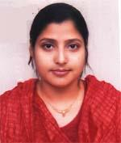 | DR. SELINA YASMIN  F/Name: Mohammad Abdul Matin  M/Name: Mst. Lutfun Nessa  BM & DC Reg. No: 37552  NID:  Cell: 01753608774  Address: 86, Nobab Road, Saniyat Mahal (1st Floor), West Sheikhghat, Sylhet  Blood Group: AB+
304 | Voter No  LM-6500304  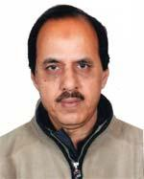 | DR. M. A. AZIZ CHOWDHURY  F/Name: Late M. A. Khalique Chowdhury  M/Name: Late Tohobun Nessa Chowdhury  BM & DC Reg. No: 44356  NID: 9196204139017  Cell: 01711300774  Address: 38, Provati, East Pir Mohalla, Amber Khana, Sylhet  Blood Group: B+
305 | Voter No  LM-6500305  No Image | DR. ABU SAYEED ABDULLAH  F/Name: Md. Arkan Ullah  M/Name:  BM & DC Reg. No:  NID:  Cell:  Address: 1, Munshi Para, Sylhet.  Blood Group:
306 | Voter No  LM-6500306  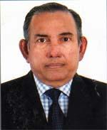 | DR. WALI MAHMUD KHAN  F/Name: Late Ali Mahmud Khan  M/Name: Late Nurunnessa Khatun  BM & DC Reg. No: 8219  NID: 9196201106003  Cell: 01758371933  Address: Pyra-I, Khan Cottage, Dorga Moholl, Sylhet  Blood Group: B+
307 | Voter No  LM-6500307  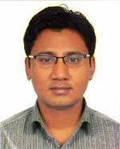 | DR. MOHAMMED EMDADUR RAHMAN  F/Name: Md. Ebadur Rahman  M/Name: Hawarun Nessa  BM & DC Reg. No: 65486  NID: 19889116242551645  Cell: 01911112873  Address: Udoyon 29/B Syedpur R/A , Majortila, Sylhet.  Blood Group: O+
308 | Voter No  LM-6500308  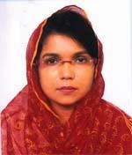 | DR. TANJINA CHOWDHURY  F/Name: Dr. Moiz Uddin Chowdhury  M/Name: Rowsan Ara Chowdhury  BM & DC Reg. No: 33839  NID: 19779196201102405  Cell: 01675001650  Address: 4/E Old Medical Colony, Rikabibazar, Sylhet  Blood Group: AB+
309 | Voter No  LM-6500309  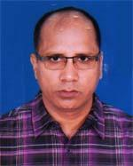 | DR. MOHAMMAD ABDUL HAI MIA  F/Name: Mohammad Abdul Goni Mia  M/Name: Banu Begum  BM & DC Reg. No: 27552  NID: 2693717167466  Cell: 01711186722  Address: Neonatology Department, SMAG Osmani Medical College  Blood Group: A+
310 | Voter No  LM-6500310  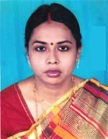 | DR. PURABI MAZUMDER  F/Name: Binoy Kumar Mazumder  M/Name: Bakul Mazumder  BM & DC Reg. No: 43491  NID: 1594121572771  Cell: 01739151648  Address: Assistant Registpar, Pediatrics, Sylhet M.A.G. Osmani Medical College Hospital  Blood Group: B+
311 | Voter No  LM-6500311  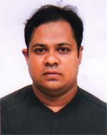 | DR. MD. KAMRUL GAFFAR  F/Name: Dewan Kamruzzaman  M/Name: Late Umme Kulsum  BM & DC Reg. No: 44358  NID: 9196217293225  Cell: 01717019195  Address: 37 Azadi Mirbox Tula, Naya Sharak, Sylhet.  Blood Group: B+
312 | Voter No  LM-6500312  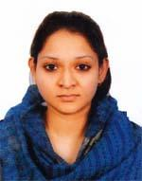 | DR. MASRABA SULTANA  F/Name: Md. Abdus Shahid  M/Name: Gulsan Ara  BM & DC Reg. No: 60892  NID: 19879196221341960  Cell: 01674374995  Address: 69-Nobopushpo, jatarpur, Sylhet.  Blood Group: B+
313 | Voter No  LM-6500313  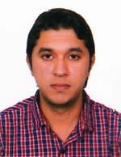 | DR. DIPYAMAN DEY  F/Name: Dilip Kumar Dey  M/Name: Shikha Dey  BM & DC Reg. No: 70178  NID: 9196217292411  Cell: 01712328673  Address: Niloy-13, Chouhatta, Sylhet  Blood Group: O+
314 | Voter No  LM-6500314  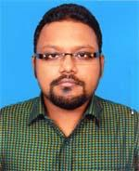 | DR. AHMED ZAHIN SHAHIB  F/Name: Prof. Dr. Jamil Ahmed  M/Name: Shirin Akhter  BM & DC Reg. No: 74149  NID: 9196216287159  Cell: 01717683983  Address: Block-B, Road-03, House-41, Surma R/A Akhalia, Sylhet.  Blood Group: O+
315 | Voter No  LM-6500315  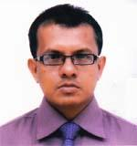 | PROFESSOR DR. MD. MASHUDUL ALOM  F/Name: Md. Aklas Uddin  M/Name: Jahanara Begom Chowdhury  BM & DC Reg. No: 27949  NID: 9196218305184  Cell: 01743332418  Address: 58 Evergreen, Zerzeri Para,Upo-Sylhet, Dist-Sylhet.  Blood Group: O+
316 | Voter No  LM-6500316  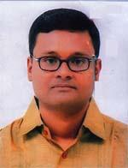 | DR. MUSHFIQUR RAHMAN  F/Name: Shafiqur Rahman  M/Name: Mirzanul Bahar  BM & DC Reg. No: 39027  NID: 9196208498406  Cell: 0172725631  Address: Rghgnabug, Uttoron-66, Barutkhana  Blood Group: A+
317 | Voter No  LM-6500317  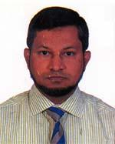 | DR. MD. NAZRUL ISLAM  F/Name: Late Md. Mostakim Ali  M/Name: Late Mustuza Khanom  BM & DC Reg. No: 28255  NID: 9196218307474  Cell: 01711484663  Address: H# 4/E, Peace Garden, Gashihila, Sylhet-3100.  Blood Group: B+
318 | Voter No  LM-6500318  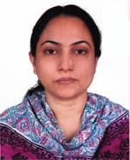 | DR. MST. EFFAT JAHAN  F/Name: Md. Abdur Mannan  M/Name: Late Momtaj Ara Begum  BM & DC Reg. No: 28620  NID: 9196218307413  Cell: 01736209992  Address: 4/E, Peace Garden, Reliable City, Gashitula, Sylhet.  Blood Group: B+
319 | Voter No  LM-6500319  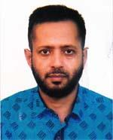 | DR. MUHAMMAD ABDUL HAFIZ  F/Name: Late Dr. M. A. Matin  M/Name: Late Afrujun Nessa  BM & DC Reg. No: 35812  NID: 9196220329400  Cell: 01711399140  Address: 33 Ronadhasu R/A , Lakripara Shibgonj, Sylhet-3100.  Blood Group: B+
320 | Voter No  LM-6500320  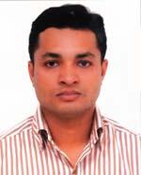 | DR. NURUL HASAN SIDDIQUEE  F/Name: Md. Ataur Rahman  M/Name: Mst. Shafia Khanom  BM & DC Reg. No: 43424  NID: 9116242580903  Cell: 01712973656  Address: Shahid Siddik Ali Road, Khidir Pur, Khadim Nagar, Sylhet.  Blood Group: B+
321 | Voter No  LM-6500321  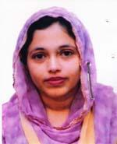 | DR. MAHFUZA RHAMAN CHOWDHURY  F/Name: Md. Azadur Rahman Chowdhury  M/Name: Syeda Raihana Khatun  BM & DC Reg. No: 44444  NID: 9196209206909  Cell: 01715045808  Address: 21 Urmi, Sonarpara, Shibgonj, Sylhet.  Blood Group: A+
322 | Voter No  LM-6500322 | DR. MOHAMMED SAHEDUL HASAN  F/Name: Md. Abdul Mukit  M/Name: Mst. Tahmina Begum  BM & DC Reg. No: 40947  NID: 9196209206908  Cell: 01979506090  Address: 21 Urmi, Sonarpara, Shibgonj, Sylhet.  Blood Group: B+
323 | Voter No  LM-6500323  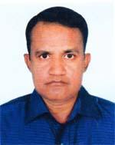 | DR. MD. SHAKHAWAT HOSSAIN  F/Name: Late Md. Samsul Alam  M/Name: Salma Khanom  BM & DC Reg. No: 35153  NID: 9196201110281  Cell: 01711822473  Address: 48, Prantik, Flat no. A-1, Mia Fazil Chist, Subidbazar, Sylhet.  Blood Group: B+
324 | Voter No  LM-6500324  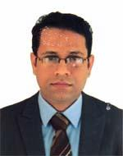 | DR. MD. ABDUL MUKTADIR QURESHI  F/Name: Md. Abdul Mugni  M/Name: Mrs. Rezia Khanom Chowdhury  BM & DC Reg. No: 43626  NID: 9196218306719  Cell: 01711988910  Address: Islamia House, 108-Kazitula Ucha sarak, Sador, Sylhet.  Blood Group: O+
325 | Voter No  LM-6500325  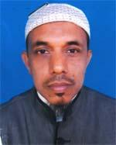 | DR. MD. ABDUR RAHMAN  F/Name: Late Tafazzul Ali  M/Name: Late Roshomoti Bibi  BM & DC Reg. No: 35996  NID:  Cell: 01714528901  Address: House-15, Block-A, Road-1, Tilagarh Sylhet, Bangladesh.  Blood Group: B+
326 | Voter No  LM-6500326  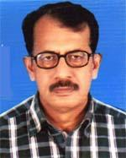 | DR. MD. NASIR UDDIN BHUIYAN  F/Name: Shamsuddin Bhuiyan  M/Name: Rabeya Khatun  BM & DC Reg. No: 13698  NID: 9196209209563  Cell: 01707077941  Address: 23/5, Etim School Road, Bagbari, Sylhet Sadar.  Blood Group: O+
327 | Voter No  LM-6500327  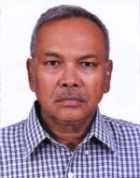 | DR. JYOTI KUSUM CHOWDHURY  F/Name: Late Kashinath Chowdhury  M/Name: Late Premoda Chowdhury  BM & DC Reg. No: 8369  NID: 9196218303266  Cell: 01819659078  Address: House No. 5, Mojumder Poll, Hawlderpara, Kalibari Road, P/S-Jalalabad, Sylhet City Corporation.  Blood Group: O+
328 | Voter No  LM-6500328  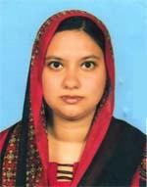 | DR. ISMOTH ARA JERIN  F/Name: Late Abdul Matin  M/Name: Shamim Ara Begum  BM & DC Reg. No: 53534  NID: 9196222350026  Cell: 01717468756  Address: 16/A, Muhona  Blood Group: n_a
329 | Voter No  LM-6500329  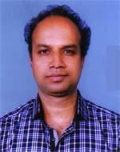 | DR. SUMON MALLIK  F/Name: Milon Kanti Mallik  M/Name: Laxmi Mallik  BM & DC Reg. No: 36405  NID:  Cell: 01727414114  Address:  Blood Group: O+
330 | Voter No  LM-6500330 | DR. ASHIM RANJAN ROY  F/Name: Satya Ranyan Roy  M/Name: Aroti Prova Roy  BM & DC Reg. No: 27258  NID: 3611137271195  Cell: 01711985753  Address: Kamaria Bhaban, 14, Dishari Howapara, Sylhet.  Blood Group: A+
331 | Voter No  LM-6500331  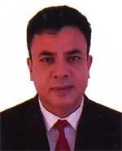 | DR. MD. FAYAZ UDDIN  F/Name: Md. Abdur Rahim  M/Name: Late Anowara Begum  BM & DC Reg. No: 25114  NID: 5821407876156  Cell: 01711021428  Address: Flat no-2c, Apon Blue Tower, 3 Sagordighirpar, Sylhet.  Blood Group: O+
332 | Voter No  LM-6500332  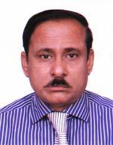 | DR. GOPI KANTA ROY  F/Name: Late Guru Saday Roy  M/Name: Suroma Rani Roy  BM & DC Reg. No: 7575  NID: 9196217292725  Cell: 01712217638  Address: Professor of Psycliatry Dept of Psycliatry. Jalalabad Ragib Rabeya Medical College, Sylhet.  Blood Group: B+
333 | Voter No  LM-6500333 | DR. RAZA AHMED NEWAZ CHOWDHURY  F/Name: Dr. Murshed Ahmed Chowdhury  M/Name: A. Z. Rowshon Zebin  BM & DC Reg. No: 77080  NID: 19919196203000029  Cell: 01737660201  Address: 12/A, Chaondrima, Subid Bazar, Sylhet, Bangladesh.  Blood Group: O+
334 | Voter No  LM-6500334  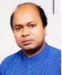 | DR. MD. ALTAF HOSSAIN  F/Name: Late Md. Afsar Uddin  M/Name: Rowshan Ara Khanam  BM & DC Reg. No: 33759  NID: 9196203127868  Cell: 0171144478  Address: Polloi #D/30, Pathantola, Sylhet.  Blood Group: O+
335 | Voter No  LM-6500335  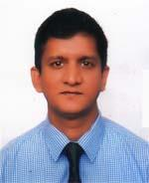 | DR. MD. ATIQUR RAHMAN LEMAN  F/Name: Md. Fazlur Rahman  M/Name: Anwara Begum  BM & DC Reg. No: 48052  NID: 9196203122965  Cell: 01725726456  Address: 103, Kazolshah, Sylhet.  Blood Group: A+
336 | Voter No  LM-6500336  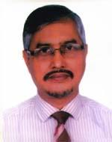 | DR. MD. BURHAN UDDIN  F/Name: Md. Monir Uddin  M/Name: Khoyrun Nessa  BM & DC Reg. No: 19301  NID: 9196222351227  Cell: 01715084115  Address: House-66, Road-44, Block-C, Shahjalal Upashahor, Sylhet-3100.  Blood Group: B+
337 | Voter No  LM-6500337 | DR. SYED MUSHAROF HUSSAIN  F/Name: Late Syed Hussain Ahmed  M/Name: Late Saleha Khanom Chy  BM & DC Reg. No: 21233  NID: 9196207177909  Cell: 01711376225  Address: 88/2, Mohona R/A, Patan Tuzla, Sylhet, Bangladesh.  Blood Group: AB+
338 | Voter No  LM-6500338 | DR. ZAKIA SULTANA  F/Name: Mohd Yusuf  M/Name: Hafeza Khatun  BM & DC Reg. No: 14527  NID: 9196201109865  Cell: 01711985996  Address: 4/C Apon Blue Tower, Sagor Digirpar , Sylhet, Bangladesh.  Blood Group: A+
339 | Voter No  LM-6500339  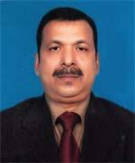 | DR. MD. MUSHAHID THAKUR  F/Name: Golam Mortuza Thakur  M/Name: Rabeya Khatun  BM & DC Reg. No: 13893  NID: 9196201109786  Cell: 01716073820  Address: 4/C Apon Blue Tower, Sagor Digirpar, Sylhet, Bangladesh  Blood Group: AB+
340 | Voter No  LM-6500340  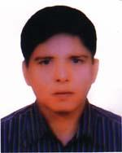 | DR. ASHOK KUMAR KUNDU  F/Name: Late Sree Surendra Nath Kundu  M/Name: Late Usha Rani Kundu  BM & DC Reg. No: 19069  NID: 9196211229066  Cell: 01711454433  Address: Associate Prof of Cardiology Cylhet Women\'s Medical College  Blood Group: B+
341 | Voter No  LM-6500341  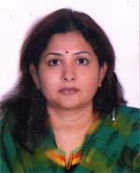 | DR. LOVELY RANI DHAR  F/Name: Biswa Ranjan Dhar  M/Name: Lakshmi Rani Dhar  BM & DC Reg. No: 46989  NID: 9196213248650  Cell: 01717020400  Address: Shopnil, 22, Mirza zansal, Sylhet.  Blood Group: A+
342 | Voter No  LM-6500342  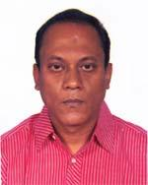 | DR. ANURUDHA PAUL  F/Name: Anrit Lal Paul  M/Name: Gouri Paul  BM & DC Reg. No: 40342  NID: 9196213256371  Cell: 01711301108  Address: 69 Sowpnil, Nirzazangal, Sylhet, 3100  Blood Group: A+
343 | Voter No  LM-6500343  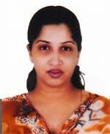 | DR. SNIGDHA DEB  F/Name: Krishna Rada Deb  M/Name: Shika Ray  BM & DC Reg. No: 49085  NID: 9196213256370  Cell: 01715575247  Address: 69, Shrepnil Mirzazangall, Sylhet.  Blood Group: O+
344 | Voter No  LM-6500344  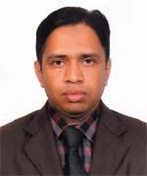 | DR. MD. ABUL HARIS  F/Name: Nurul Haq  M/Name: Angura Begum  BM & DC Reg. No: 50023  NID:  Cell: 01712656809  Address: Vill-Dalaichar, Post-Kanaigaut, Dist- Sylhet.  Blood Group: B+
345 | Voter No  LM-6500345  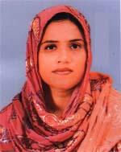 | DR. PARVEEN AFROZ CHOWDHURY  F/Name: Late Reasat Ali Chowdhury  M/Name: Late Ful Banu Nessa  BM & DC Reg. No: 42590  NID: 2695431004817  Cell: 01792252436  Address: 8, Shah Shikander R/A, Shahjalal University Gate, Sylhet  Blood Group: A+
346 | Voter No  LM-6500346 | DR. MD. ISFAQ ZAMAN SHOJIB  F/Name: Prof. M. A. Muhid  M/Name: Mrs. Asma Chowdhury  BM & DC Reg. No: 57312  NID:  Cell: 01716162240  Address: 67, Mousumi, London Tower, 3/A, Mirabazar, Sylhet  Blood Group: A+
347 | Voter No  LM-6500347  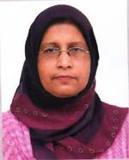 | DR. SYEDA SHAMIM ARA  F/Name: Syed Abdul Mukit  M/Name: Jobeda Khanom  BM & DC Reg. No: 13163  NID: 9196220328689  Cell: 01711967291  Address: 68 Pushpayon, Senpara, Shibgonj, Sylhet  Blood Group: O+
348 | Voter No  LM-6500348  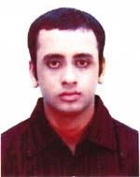 | DR. REFAT RASUL  F/Name: Khaledur Rasul  M/Name: Momotaz Begum  BM & DC Reg. No: 58857  NID: 9196217293201  Cell: 01558347397  Address: Rasul Vila, Azadi-58 Mirboxtula, Nayasarak, Sylhet  Blood Group: B+
349 | Voter No  LM-6500349  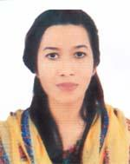 | DR. NAOMI KHALED  F/Name: Soreqoume Mohammad Khaled  M/Name: Nazmun Nahar Chy  BM & DC Reg. No: 70319  NID: 9196201101503  Cell: 01728456679  Address: 61, Housing Estate, Amborkhana Sylhet  Blood Group: AB+
350 | Voter No  LM-6500350  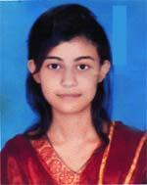 | DR. ARAF KHAN  F/Name: Dr. Md. Ansar Khan  M/Name: Mrs. Kohlnoor Akther  BM & DC Reg. No: 75250  NID: 19929196211000168  Cell: 01675288221  Address: Bithika A/2, Nowapara Lamabazar,Niugarden Sylhet  Blood Group: O+
351 | Voter No  LM-6500351  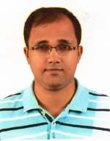 | DR. MD. MAHFUZ AKHTAR KHAN  F/Name: Md. Akhtar Hussain Khan  M/Name: Monirunnesa Chowdhury  BM & DC Reg. No: 64665  NID: N/A  Cell: 01766071567  Address: Raynogor, Shebok-81, Sylhet  Blood Group: B+
352 | Voter No  LM-6500352  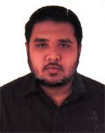 | DR. SHAMRAT ADNAN CHOWDHURY  F/Name: Abu Syed Abdullah Chowdhury  M/Name: Ferdusi Abdullah Diba  BM & DC Reg. No: 73318  NID: 19909196212000035  Cell: 01718059990  Address: Daroga Bari, Rajanigandha-01, Bhangatikan, Sheikghat, Sylhet-3100  Blood Group: B+
353 | Voter No  LM-6500353 | DR. MD. MOHIUS SUNNAH  F/Name: Md. Ashrafuz Zaman  M/Name: Luthfa Begum  BM & DC Reg. No: 68859  NID: 9113136296423  Cell: 01753821293  Address: Vill-Piruzpur, P.O-Sylhet Sadar, P.S-Dakshin Surma, Dist-Sylhet  Blood Group: B+
354 | Voter No  LM-6500354  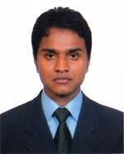 | DR. MD. AHMED HUSSAIN  F/Name: Md. Abdul Malik  M/Name: Mst. Khanom Begum  BM & DC Reg. No: 73764  NID: 19909196215000071  Cell: 01722640579  Address: Uddipon 86/8, Mirabazar, Sylhet.  Blood Group: AB+
355 | Voter No  LM-6500355  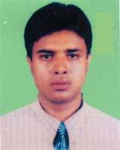 | DR. MOHAMMAD SHAIFULLAH  F/Name: Mohammad Nur  M/Name: Noorjahan Begum  BM & DC Reg. No: 39191  NID: 1521801578985  Cell: 01711485071  Address: Noorjahan Hspital, Sylhet  Blood Group: O+
356 | Voter No  LM-6500356  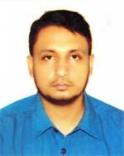 | DR. MD. SHAH ALAM  F/Name: Late Md. Idris Ali  M/Name: Musammat Gulbahar  BM & DC Reg. No: 65487  NID: 9113185310547  Cell: 01716888154  Address: Vill-Nizyiwb, P.O-Lalabazar, P.S-South Surma, Dist-Sylhet  Blood Group: O+
357 | Voter No  LM-6500357  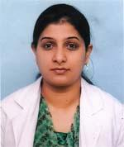 | DR. REZWANA MIRZA  F/Name: Late Mirza Abdul Hannan  M/Name: Dr. Asia Khatun Chowdhury  BM & DC Reg. No: 35613  NID: 9196209203558  Cell: 01738984144  Address: Ghurni 3/B, Old Medical College Sylhet-3100.  Blood Group: B+
358 | Voter No  LM-6500358  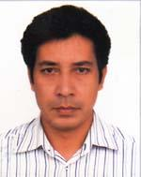 | DR. MOHAMMAD ABDUL QUADIR  F/Name: Mohammad Abdul Awal  M/Name: Mrs. Fawzia Begum  BM & DC Reg. No: 33762  NID: 9196209203557  Cell: 01717918892  Address: Ghurni B/B, Old Medical Colony, Sylhet.  Blood Group: B+
359 | Voter No  LM-6500359  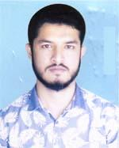 | DR. MIZANUR RAHMAN  F/Name: Azizur Rahman  M/Name: Hasna Begum  BM & DC Reg. No: 69601  NID: 9110855665958  Cell: 01722220170  Address: Vill/P.O-Brahman Shasan, P.S-Osmaninagor, Dist-Sylhet  Blood Group: O+
360 | Voter No  LM-6500360  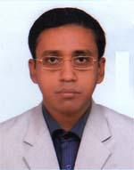 | DR. BISHWAJIT CHAKRABARTY  F/Name: Biresh Chandra Chakrabarty  M/Name: Binapani Chakrabarty  BM & DC Reg. No: 53056  NID: 9196220331120  Cell: 01752450999  Address: House No # 19, Shadipur(R/A), Shibgonj, Sylhet  Blood Group: A+
361 | Voter No  LM-6500361  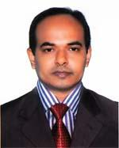 | DR. MOHAMMAD SHAMSUL ALAM  F/Name: Md. Golam Rasul  M/Name: Mrs. Feroza Khanom  BM & DC Reg. No: 33725  NID: 9196203123328  Cell: 01911681251  Address: 188/1, Miah Fazil Chist (1st Floor)Subid Bazar, Sylhet  Blood Group: A+
362 | Voter No  LM-6500362  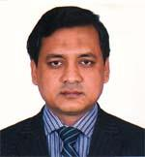 | DR. MD. MOYEEN UDDIN  F/Name: Late Md. Siddeak Ali  M/Name: Mrs. Saleha Khatun  BM & DC Reg. No: 28859  NID: 2697556418158  Cell: 01715172964  Address: 122, Housing Estate, Sylhet  Blood Group: O+
363 | Voter No  LM-6500363  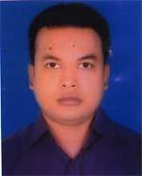 | DR. MOHAMMAD ABDULLAH AL HELAL  F/Name: Nur Ahad Sarker  M/Name: Mrs. Mahmuda Ahad  BM & DC Reg. No: 58507  NID: 19849196201102659  Cell: 01712806482  Address: 48, Praantik, Miah Fazil Chist, East Subidbazar, Sylhet  Blood Group: B+
364 | Voter No  LM-6500364  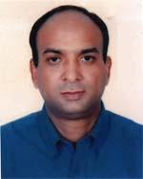 | DR. JAHIR AHMED  F/Name: Md. Abdul Matin  M/Name: Mrs. Somirun Nessa  BM & DC Reg. No: 30887  NID: 9196209209242  Cell: 01711383092  Address: Akota-09, Atim School Road, Bagbari, Sylhet  Blood Group: AB+
365 | Voter No  LM-6500365  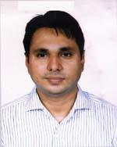 | DR. MD. SHAHNEWAZ RAHMAN  F/Name: Luthfur Rahman  M/Name: Anowara Rahman  BM & DC Reg. No: 49328  NID: 9123808988261  Cell: 01911116161  Address: Shopnil, Ronkeli (South) Post+P.s=Golapgonj, Sylhet  Blood Group: O+
366 | Voter No  LM-6500366  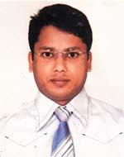 | DR. MOHAMMED KAMAL HOSSAIN  F/Name: Mohammed Abdur Rahim  M/Name: Mohammed Hazera Begum  BM & DC Reg. No: 49726  NID: 9196203131313  Cell: 01916129580  Address: Doctor\'s qunrler, Upozilla Health Complex, Fenchuganj  Blood Group: B+
367 | Voter No  LM-6500367  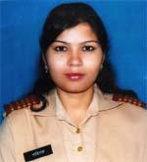 | DR. SHAHINARA ISLAM  F/Name: Md. Shahidul Islam  M/Name: Mrs. Zahura Islam  BM & DC Reg. No: 57500  NID: 2650898262743  Cell: 01952881013  Address: Doctors Quarter, Upazilla Health Complex Fenchuganj, Sylhet  Blood Group: O+
368 | Voter No  LM-6500368  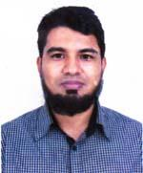 | MD. RASHADUL HOQUE  F/Name: Md. Mojibul Hoque  M/Name: Rokeya Begum  BM & DC Reg. No: 55717  NID: 19839196203121094  Cell: 01721594141  Address: Samad Plaza (4th Floor) Fenchugonj, Sylhet  Blood Group: A+
369 | Voter No  LM-6500369  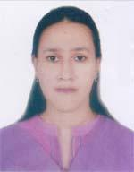 | DR. NAHIDA ZAFRIN  F/Name: Faruque Ahmed  M/Name: Anwara Khatun  BM & DC Reg. No: 33764  NID: 2698877380613  Cell: 01911701525  Address: 107, Ekota, North Bagbari, Sylhet-3100  Blood Group: A+
370 | Voter No  LM-6500370  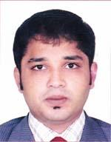 | DR. DEBASHISH DEY  F/Name: Dilip Ranjan Dey  M/Name: Anjana Dey  BM & DC Reg. No: 50742  NID: 9196203131275  Cell: 01771966855  Address: 9/D, Paradise Home, Bithika A/15, Noapara, Lamabazar, Sylhet  Blood Group: AB+
371 | Voter No  LM-6500371  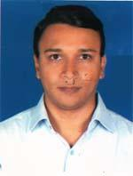 | DR. MD. ABDUR ROUF MUNNA  F/Name: Md. Abdul Karim  M/Name: Ayesha Begum  BM & DC Reg. No: 55116  NID: 9196207170098  Cell: 01710889922  Address: 37, Jalalabad G/A, Ambarkhan, Sylhet  Blood Group: O+
372 | Voter No  LM-6500372  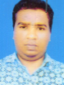 | DR. MD. ABDULLAH AL MEHEDI  F/Name: Md. Abdul Wahed  M/Name: Meherunnessa  BM & DC Reg. No: 34001  NID: 19759129403000001  Cell: 01937405583  Address: UHC Zakaigonj, Sylhet.  Blood Group:
373 | Voter No  LM-6500373  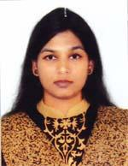 | DR. SHAHRIN KIBRIA  F/Name: Md. Golam Kibriya  M/Name: Husnaura Khanam  BM & DC Reg. No: 76993  NID: 19912695051000069  Cell: 01711956291  Address: 16/3 Kazi Ilias, Zindabazar, Sylhet  Blood Group: O+
374 | Voter No  LM-6500374 | DR. TAMALIKA BHATTACHARJEE  F/Name: Dr. Tanmoy Bhattacharjee  M/Name: Dr. Gouri Rani Das  BM & DC Reg. No: 69599  NID: 19909196203000063  Cell: 01722338612  Address: 6,Kazolshah, Kazalshah Medical College Road, Sylhet  Blood Group: B+
375 | Voter No  LM-6500375 | DR. RATAN CHANDRA BHOWMIK  F/Name: Mati Lal Bhowmik  M/Name: Jorona Rani Bhowmik  BM & DC Reg. No: 47127  NID: 1594116381031  Cell: 01716241036  Address: Room No. 501, A Block, BSMMU.  Blood Group: B+
376 | Voter No  LM-6500376  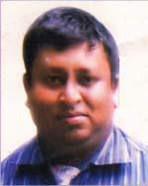 | DR. RANJIT DEBNATH  F/Name: Late Atul Chandra Debnath  M/Name: Late Bina Devi  BM & DC Reg. No: 36462  NID: 9110840751429  Cell: 01912713104  Address: 207/2, porshi, kewapara, mirer moidan, sylhet  Blood Group: B+
377 | Voter No  LM-6500377  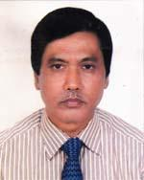 | DR. NIRMAL KANTI DEY  F/Name: Nibaran Chandra Das  M/Name: Renu Bala Das  BM & DC Reg. No: 16670  NID: 9110840751441  Cell: 01726382678  Address: C/O Liton Medical Corner Hafizcity, Post-Goala Bazar, Osmaninagar, Sylhet  Blood Group: A+
378 | Voter No  LM-6500378 | DR. MOHAMMAD ABDUL HYE  F/Name: Late Md. Jamshed Ali  M/Name: Hamida Khathun  BM & DC Reg. No: 21887  NID: 19669196204139223  Cell: 01711737043  Address: 1/A, Flat-2B, Housingestate Gate, Sylhet-3100, Bangladesh.  Blood Group: O+
379 | Voter No  LM-6500379  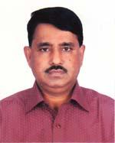 | DR. MD. ANSAR KHAN  F/Name: Late Md. Warish Khan  M/Name: Late Ayatun Nessa  BM & DC Reg. No: 16842  NID: 9196211231032  Cell: 01711444842  Address: Associate Prof. Pharmceties Depat. SOMC.  Blood Group: O+
380 | Voter No  LM-6500380  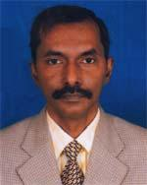 | DR. MANOJIT MAJUMDER  F/Name: Bibekananda Majumder  M/Name: Usha Majumder  BM & DC Reg. No: 19635  NID: 19669196211236560  Cell: 01552360088  Address: Dept. of Bilchemistry mag Osmani Medical College, Sylhet  Blood Group: B+
381 | Voter No  LM-6500381  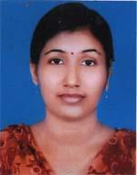 | DR. GAURI RANI DEB NATH  F/Name: Hiralal Deb Nath  M/Name: Aunima Deb Nath  BM & DC Reg. No: 45426  NID: 9110840751430  Cell: N/A  Address: Porshi, 207/2 , Kewapara Mirermoy, Sylhet  Blood Group: O+
382 | Voter No  LM-6500382  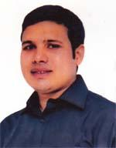 | DR. ABUL FOYEZ ALI AHMED  F/Name: Late Shams Uddin Ahmed  M/Name: Mrs. Fatima Begum  BM & DC Reg. No: 47923  NID: 9196219316213  Cell: 01712262056  Address: 94, Mitali R/A, Raynogor, Sylhet  Blood Group: O+
383 | Voter No  LM-6500383  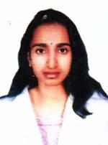 | DR. TAHMINA BEGUM  F/Name: Siraj Uddin  M/Name: Jahanara Chowdhury  BM & DC Reg. No: 50306  NID: 19849196205155204  Cell: 01729596399  Address: 112/1 A Amborkhana Boro Bazar R/A, Sylhet  Blood Group: O+
384 | Voter No  LM-6500384  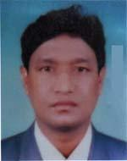 | DR. ARUN KUMAR BAISHNAB  F/Name: Keashor Chandra Baishnab  M/Name: Mogoda Bala Baishnab  BM & DC Reg. No: 28743  NID: 2697557395167  Cell: 01712124711  Address: 189 Adnan Complex, Kanishail, Sylhet  Blood Group: B+
385 | Voter No  LM-6500385  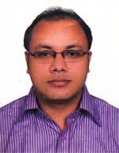 | DR. SUBRATA RAY  F/Name: Sushanta Ray  M/Name: Shiba Ray  BM & DC Reg. No: 40645  NID: 9196213258095  Cell: 01711156641  Address: Saptadipa 11/2 , Jamtola, Sylhet  Blood Group: O+
386 | Voter No  LM-6500386  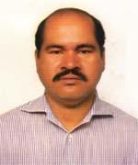 | DR. MD. HOSSAIN (ROBIN)  F/Name: Late Nur Ahmed Sowdagor  M/Name: Late Mosuda Begum  BM & DC Reg. No: 25397  NID: 9196204138596  Cell: 01751984570  Address: 217, West Pirmohalla, Housing Estate, Sylhet-3100.  Blood Group: A+
387 | Voter No  LM-6500387  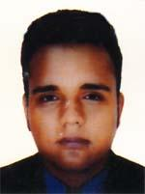 | DR. MOYUKH CHOWDHURY  F/Name: Prof. Dr. Mrigen Kumar Das Chowdhury  M/Name: Ratna Das Chowdhury  BM & DC Reg. No: 70832  NID: 9196202116545  Cell: 01767008844  Address: Flat 7B, Thikana Tower, Nayasarak, Sylhet-3100  Blood Group: O+
388 | Voter No  LM-6500388  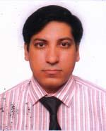 | DR. MD. NURUL ALAM KHAN  F/Name: Md. Nurul Amin Khan  M/Name: Nasima Khanam  BM & DC Reg. No: 33518  NID: 9196217292485  Cell: 01726017272  Address: Red Crescent Materity Hospital, Chowhatta, Sylhet-3100  Blood Group: AB+
389 | Voter No  LM-6500389  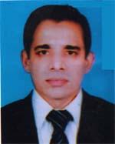 | DR. S M HABIBULLAH (SELIM)  F/Name: Mohd. Muslim  M/Name: Nabila Khanom  BM & DC Reg. No: 25818  NID: 9196222347709  Cell: 01711984610  Address: house-42, Road-37, Block-C, Shahjalal Upasahar, Sylhet-3100  Blood Group: B+
390 | Voter No  LM-6500390  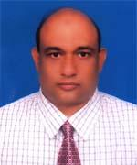 | DR. EMAD HUSSAIN CHOWDHURY  F/Name: Late Saidul Hussain Chowdhury  M/Name: Late Rahima Chowdhury  BM & DC Reg. No: 19344  NID: 9196211229068  Cell: 01711388431  Address: Upozila Health Complex, Golapganj, Sylhet  Blood Group: O+
391 | Voter No  LM-6500391  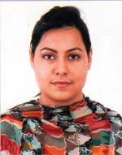 | DR. NUSRAT FARHANA CHOWDHURY  F/Name: Dr. Md. Ehteshamul Huq Chowdhury  M/Name: Thamin Farhana Chowdhury  BM & DC Reg. No: 75473  NID: 19919196216000010  Cell: 01673191614  Address: 14/3 Dishari, Hawapara, Sylhet  Blood Group: O+
392 | Voter No  LM-6500392  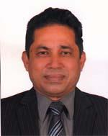 | DR. MAHMUDUL MAJID CHOUDHURY  F/Name: Late Dr. Abdul Mukith Choudhury  M/Name: Late Faizunnessa Choudhury  BM & DC Reg. No: 7583  NID: 9196207176588  Cell: 01711920152  Address: House No. 14, Road No. 2, Block B, Surma R/A Atlhlia Sylhet  Blood Group: B+
393 | Voter No  LM-6500393  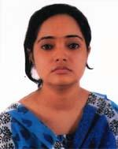 | DR. ISRATH ZAHAN KHAN  F/Name: Dr. Md. Iqbal Khan  M/Name: Shamsunnesa Siddiqua  BM & DC Reg. No: 61208  NID: 9196218303154  Cell: 01681864043  Address: House no-301, Road-03, Block-H, Shajalaa Uposhohar, Sylhet  Blood Group: A+
394 | Voter No  LM-6500394  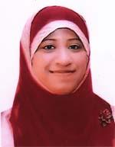 | DR. NAIMA CHOWDHURY  F/Name: Md. Golam Yeahia Chowdhury  M/Name: Joshna Chowdhury  BM & DC Reg. No: 64013  NID: 19899116242554148  Cell: 01671891749  Address: House no-25, Road no-04, Purobi R/A, Islampur, Sylhet  Blood Group: A+
395 | Voter No  LM-6500395  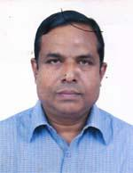 | DR. ZAKIR HUSSAIN CHOWDHURY  F/Name: Dr. M. Hussain Chowdhury  M/Name: Akhtarunnessa Chowdhury  BM & DC Reg. No: 34320  NID: 9196216287886  Cell: 01819656704  Address: 51,Tatipara, Sylhet  Blood Group: B+
396 | Voter No  LM-6500396  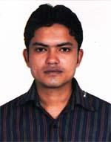 | DR. JABER AHMED  F/Name: Md. Sobur  M/Name: Fateha Khanom  BM & DC Reg. No: 53607  NID: 5818073398712  Cell: 01712879457  Address: Dhansiri-19, Alauddin vila, Sahi Eidgah, Sylhet  Blood Group: O+
397 | Voter No  LM-6500397  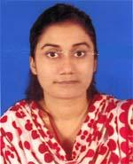 | DR. ZENIA SIKDER  F/Name: Dr. Bikash Sikder  M/Name: Dr. Ivy Purkayastha  BM & DC Reg. No: 78222  NID: 19911919621500018  Cell: 01920258073  Address: Anabil, Block-C, House No.-126, Dophadighir Purbo Par, Sylhet  Blood Group: O+
398 | Voter No  LM-6500398  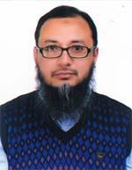 | DR. MD. RASHEDUL HAQUE  F/Name: Md. Mahbubul Haque  M/Name: Rokeya Khanam Siddiqua  BM & DC Reg. No: 27499  NID: 9196205153348  Cell: 01712589131  Address: 27, Jalali kalbakhani R/A, Electric Supply, Amberkhana, Sylhet  Blood Group: AB+
399 | Voter No  LM-6500399  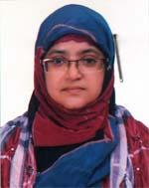 | DR. MAHJUBA UMME SALAM  F/Name: Md. Abdus Salam Mollah  M/Name: Mrs. Mahatabun Nessa  BM & DC Reg. No: 27500  NID: 9196205153349  Cell: 01711339940  Address: 27 Kalbakhani, Electric Supply, Ambor Khana, Sylhet  Blood Group: A+
400 | Voter No  LM-6500400 | DR. MUHAMMAD HEZBULLAH  F/Name: Late Muhammad Saifullah  M/Name: Mrs. Rashida Akhter  BM & DC Reg. No: 28328  NID: 9196203129317  Cell: 01717020500  Address: 172, Flat no 1(1st Floor), South Kazolshah, Sylhet  Blood Group: O+
401 | Voter No  LM-6500401  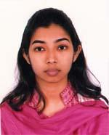 | DR. SHARMILA NATH  F/Name: Dr. Dipankar Nath Talokder  M/Name: Dr. Shukla Rani Das  BM & DC Reg. No: 75537  NID: 19939196202000086  Cell: 01675612244  Address: 32/B Meghna, Swaraj Bhaban, Dariapara, Sylhet  Blood Group: AB+
402 | Voter No  LM-6500402 | DR. M. M. JAHANGIR ALAM  F/Name: Munsi Abul Hashem  M/Name: Ayasha Akthar  BM & DC Reg. No: 25931  NID: 2693625676463  Cell: 01713206265  Address: 96, Kazal Shah, Sylhet  Blood Group: A+
403 | Voter No  LM-6500403 | DR. MD. JAHANGIR ALAM  F/Name: Md. Majal Ali  M/Name: Hawa Khatun  BM & DC Reg. No: 22600  NID: 19679196201102364  Cell: 01711148053  Address: 4/D, Kakoli, Old Medical Colony, Sylhet  Blood Group: A+
404 | Voter No  LM-6500404  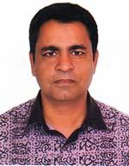 | DR. MOHAMMED ABDUL AHAD  F/Name: Hafiz Md. Firuj  M/Name: Shahanara Chowdhury  BM & DC Reg. No: 33914  NID: 19749196210212183  Cell: 01711440643  Address: House # 22, Road # 2, Block # C, Shaplabag R/A, Sylhet  Blood Group: B+
405 | Voter No  LM-6500405  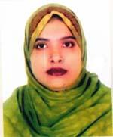 | DR. SHAMIMA AKTER  F/Name: Shafikur Rahman  M/Name: Sirsjunnessa Khanam  BM & DC Reg. No: 41522  NID: 19769196210223268  Cell: 01712059233  Address: House-22, Road-22, Block-C, Shaplabag R/A, Sylhet  Blood Group: A+
406 | Voter No  LM-6500406  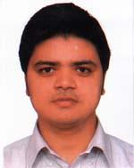 | DR. SULTAN MUHAMMAD KASHEM SHARIF  F/Name: Rahim Uddin Ahmed  M/Name: Anwara Shirin  BM & DC Reg. No: 41843  NID: 9196215277608  Cell: 01716307589  Address: House-71, Road-3, Block-F, Shajalal Uposhohor, Sylhet-3100  Blood Group: A+
407 | Voter No  LM-6500407  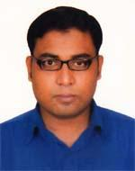 | DR. MD. SAIKUL ISLAM  F/Name: Md. Ziaul Hoque  M/Name: Alea Begum  BM & DC Reg. No: 57283  NID: 9014785132458  Cell: 01717508256  Address: Doctor\'s Quarter, Upazilla Health Complex Jagannathpur, Sunamgonj  Blood Group: B+
408 | Voter No  LM-6500408 | DR. MD. OLIUR RAHMAN ADNAN  F/Name: Late Moulana Shamsuzzaman  M/Name: Rahima Khanom  BM & DC Reg. No: 45785  NID: 9196212238789  Cell: 01722083690  Address: 13/C, Shuvecha, Sekghat, Sylhet  Blood Group: O+
409 | Voter No  LM-6500409  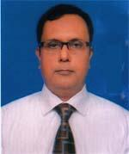 | DR. HIMANGSHU BARDHAN  F/Name: Late Rasa Ranjan Bardhan  M/Name: Late Charu Bala Bahrdhan  BM & DC Reg. No: 18944  NID: 9196203122011  Cell: 01712288938  Address: Pathology, Sylhet MAG Osmani Medical College Hospital, Sylhet  Blood Group: B+
410 | Voter No  LM-6500410  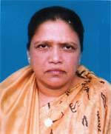 | DR. HUSNE ARA BEGUM  F/Name: Late Dr. Md. Musharrof Ali  M/Name: Late Nurjahan Begum  BM & DC Reg. No: 57530  NID: 9196201102160  Cell: 01719585037  Address: Samoli-5, old Medical colony  Blood Group: B+
411 | Voter No  LM-6500411  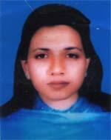 | DR. FARZANA TAZIN  F/Name: Dr. Akhlasul Mumin  M/Name: Dr. Jahan Ara Begum  BM & DC Reg. No: 39213  NID: 2991650161301  Cell: 01716685060  Address: Taif Mohol, 29, Surma R/A, Sagar Dighirpar, Sylhet  Blood Group: A+
412 | Voter No  LM-6500412  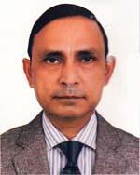 | DR. JAYANTA KUMAR DAS  F/Name: Rama Kanta Das  M/Name: Basanti Das  BM & DC Reg. No: 16645  NID: 9196213249969  Cell: 01711896326  Address: Flat No. # 8/B, Thikana Tower, Nayasarak, Sylhet  Blood Group: O+
413 | Voter No  LM-6500413  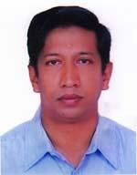 | DR. TAWFIQ-E-ELAHI CHOWDHURY  F/Name: Taufiqul Ambia Chowdhury  M/Name: Salma Khanam Chowdhury  BM & DC Reg. No: 33492  NID: 19749196221346750  Cell: 01711940078  Address: Tawfiq Villa, Kllanpur : 9, Burhan Uddin Road, Tilaghor, Sylhet 3100  Blood Group: O+
414 | Voter No  LM-6500414 | DR. SUDIPTA GOPE  F/Name: Mati Lal Gope  M/Name: Arati Purkayastha  BM & DC Reg. No: 34388  NID: 9196221339826  Cell: 01712940870  Address: House No. 12/A, Sadipur, Shibgonj  Blood Group: O+
415 | Voter No  LM-6500415  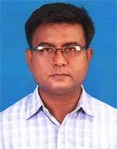 | DR. MALAY KUMAR SUR CHOWDHURY  F/Name: Bijon Kumar Sur Chowdhury  M/Name: Monju Rani Sur Chowdhury  BM & DC Reg. No: 27506  NID: 9196221340315  Cell: 01712881555  Address: House # 12/A, Sadipur, Sibgonj  Blood Group: O+
416 | Voter No  LM-6500416  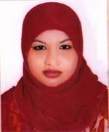 | DR. SYEDA RAHIMA AKHTER RUMI  F/Name: Late Syed Khalilur Rahman  M/Name: Mrs.nurunnahar Begum  BM & DC Reg. No: 63880  NID: 19879196222355414  Cell: 01717414000  Address: House # 262, Road # 2, Block-H, Shahjalal Upashahar, Sylhet  Blood Group: B+
417 | Voter No  LM-6500417 | DR. MD. AL MAHIR FERDOUS  F/Name: Dr. Md. Abdul Quddus  M/Name: Fourjia Sultana Lodi  BM & DC Reg. No: 54914  NID: 9196201102361  Cell: 01711-042145  Address: Subid Bazar, Excel Tower, Flat- FDG 8th Floor, Sylhet.  Blood Group: A+
418 | Voter No  LM-6500418  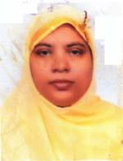 | DR. SYEDA TYUBA BEGUM  F/Name: Late Syed Md. Yakub  M/Name: Late Syeda Samsunnahar Begum  BM & DC Reg. No: 33702  NID:  Cell: 01712233322  Address: 153, Nawab Road, Kazalshah, Sylhet  Blood Group: O+
419 | Voter No  LM-6500419  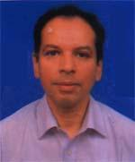 | DR. ALAMGIR ADIL SAMDANY  F/Name: Mr. Mohit Uddin Ahmed  M/Name: Mrs. Anwara Ahmed  BM & DC Reg. No: 26995  NID:  Cell: 01778208588  Address: 15/A Evergreen, Kumarpara, Sylhet  Blood Group: B+
420 | Voter No  LM-6500420  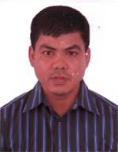 | DR. ANJAN KUMAR SINGHA  F/Name: Moni Chandra Singha  M/Name: Sushila Devi  BM & DC Reg. No: 33028  NID: 9196220333959  Cell: 01715140530  Address: Alpona 72, Senpara Sibgonj,Sylhet  Blood Group: O+
421 | Voter No  LM-6500421  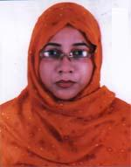 | DR. UMME SAYEEDA BILKISH  F/Name: Abdul Wahedpahlawon  M/Name: Shoheli Begum  BM & DC Reg. No: 31558  NID: 9196211236054  Cell: 01711462737  Address: Asiana, Aornob 48/1,Nuraar-Moidan, Sylhet  Blood Group: B+
422 | Voter No  LM-6500422  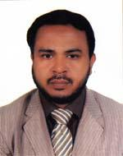 | DR. CHOWDHURY FOYZUR ROB  F/Name: Abdur Rob Chowdhury  M/Name: Laila Rob Chowdhury  BM & DC Reg. No: 27307  NID: 9196211236055  Cell: 01715250800  Address: Asiana, Aornob 48/1 Mirar-Maidan, Sylhet  Blood Group: O+
423 | Voter No  LM-6500423 | DR. TAHSIN EZAZ CHOWDHURY  F/Name: Ezazul Haq Chowdhury  M/Name: Saki-a-kawser  BM & DC Reg. No: 73735  NID: 19909196201000031  Cell: 01726449441  Address: Flat C, 2nd Floor, Paarijath Babhan, Dargah Moholla, Sylhet  Blood Group: O+
424 | Voter No  LM-6500424 | DR. RABEYA BEGUM  F/Name: Dr. M.A.Matin  M/Name: Mrs. Kohinur Nahar  BM & DC Reg. No: 33890  NID: 2696536936350  Cell: 01711165878  Address: Ibnsina Hospital, Sylhet.  Blood Group: AB+
425 | Voter No  LM-6500425  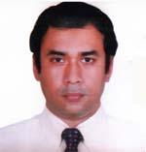 | DR. SYED ALAMGIR SAFWATH  F/Name: Prof. Dr. Syed Luqueman Ali  M/Name: Mrs. Shahma Luqueman  BM & DC Reg. No: 29315  NID: 2692619469077  Cell: 01717064725  Address: House-33, Road-22, Block-B, Shahjalal Uposhohor, Sylhet  Blood Group: O+
426 | Voter No  LM-6500426  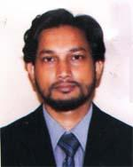 | DR. MD. ANAMUL HAQUE  F/Name: Tofazzul Ali  M/Name: Rahimun Nessa  BM & DC Reg. No: 46161  NID: 9196209203729  Cell: 01714109303  Address: 37, Ali Manjil, Sagar Digir Par, Sylhet-3100  Blood Group: AB+
427 | Voter No  LM-6500427  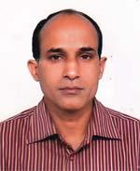 | DR. SUJIT KUMAR PAUL  F/Name: Late Narendra Kumar Paul  M/Name: Late Kollany Paul  BM & DC Reg. No: 29334  NID: 9196209198474  Cell: 01712130900  Address: 62/2, Rahman Monjeel, Road No. 2, Gopal Tila, Tilaghor-Sylhet  Blood Group: B+
428 | Voter No  LM-6500428  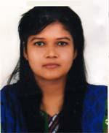 | DR. FAHMIDA JABEEN  F/Name: Dr. M. A. Hye  M/Name: Shirin Akhter  BM & DC Reg. No: 68656  NID: 19889196201110274  Cell: 01765735340  Address: 48, Pran Tik, Miah Fazil Chist, East Subid Bazar, Sylhet  Blood Group: B-
429 | Voter No  LM-6500429  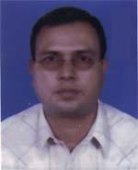 | DR. AJOY KUMAR DUTTA  F/Name: Naliny Ranjan Dutta  M/Name: Anjali Dutta  BM & DC Reg. No: 28189  NID: 2696352227463  Cell: 01711139269  Address: Flat-A-7, Barobhuya Tower, 27-Kazi-Ilias, Zinda Bazar, Sylhet  Blood Group: O+
430 | Voter No  LM-6500430  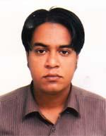 | DR NAHIAN AHMED CHOWDHURY  F/Name: Late Shafique Ahmed Chowdhury  M/Name: Ruby Ahmed Chowdhury  BM & DC Reg. No: 59026  NID: 825 014 5516  Cell: 01750674147  Address: Nibas-C-7, West Patantula, Modina Market, Sylhet  Blood Group: A+
431 | Voter No  LM-6500431  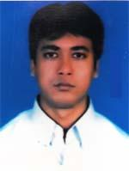 | DR. APURBA KISHORE PAUL  F/Name: Dharani Kanta Paul  M/Name: Ajita Rani Paul  BM & DC Reg. No: 36468  NID: 9196208191299  Cell: 01715294188  Address: 54/2, Samira Lodge, Block-B, Pollobi Ponitula, Sylhet  Blood Group: B+
432 | Voter No  LM-6500432  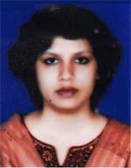 | DR. BARNALI SINHA  F/Name: Bhuben E Swar Sinha  M/Name: Basonti Sinha  BM & DC Reg. No: 36878  NID: 9196208191300  Cell: 01712277290  Address: 54/2, Samira :odge, Block-B, Pollobi, Ponitula Sylhet  Blood Group: A+
433 | Voter No  LM-6500433 | DR. CHOWDHURY MOHAMMAD WALID  F/Name: Chowdhury Mohammad Wasil Ali  M/Name: Late Rowshon Ara Chowdhury  BM & DC Reg. No: 40698  NID: 9196209200221  Cell: 01711781377  Address: Rowshon Mahal, West Patantula, Sylhet  Blood Group: A+
434 | Voter No  LM-6500434  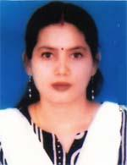 | DR. MINATI SINHA  F/Name: Late Kunjeshar Singha  M/Name: Laxmi Sinha  BM & DC Reg. No: 28179  NID: 9196211232429  Cell: 01715453565  Address: 61/1, Meghna -B, Dariapara, Sylhet  Blood Group: A+
435 | Voter No  LM-6500435  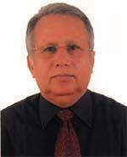 | DR. ABU HASAN RUHUL AMIN  F/Name: Haji Mohd Towhid Ali  M/Name: Badrunnessa Begum  BM & DC Reg. No: 7959  NID: passportaf65106  Cell: 01732328336  Address: House-4, Road-19, Block-B, Shahjalal Uposhahar, Sylhet  Blood Group: B+
436 | Voter No  LM-6500436 | DR. ALHLAQ AHMED  F/Name: Mohammad Ziaul Haque  M/Name: Jaheda Khaton  BM & DC Reg. No: 28246  NID: 9196201102161  Cell: 01715002554  Address: 5/E, Peace Garden, Ghashi Tula Sylhet.  Blood Group: A+
437 | Voter No  LM-6500437  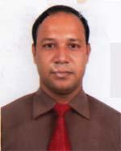 | DR. ABUL KALAM AZAD  F/Name: Abdul Hamid  M/Name: Mrs. Hasina Begum  BM & DC Reg. No: 35147  NID: 1221309352828  Cell: 01711111429  Address: 171, Parku House, south Kajal Shah, Sylhet  Blood Group: AB+
438 | Voter No  LM-6500438 | DR. MOHAMMAD GOLAM ROB MAHMUD SHUYEB  F/Name: Dr. Mohammad Golam Montaqua  M/Name: Mrs. Jahanara Begum  BM & DC Reg. No: 34819  NID: 9196211236579  Cell: 01720565215  Address: Bustan 138 Nowab road, Kajal shah Sylhet  Blood Group: AB+
439 | Voter No  LM-6500439 | DR. AZIZUL QADAR MD. ABDUL HYE  F/Name: Late Md. Abdul Mannan  M/Name:  BM & DC Reg. No:  NID:  Cell:  Address: A Rob Monzil (2nd flooer) 21, Jllarpar, Sylhet.  Blood Group:
440 | Voter No  LM-6500440  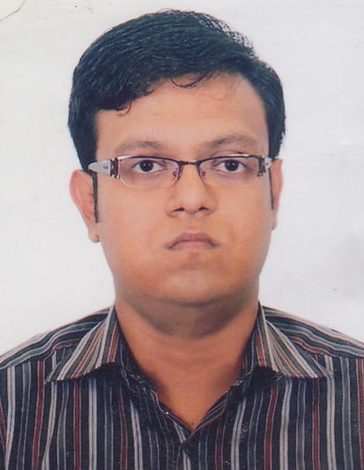 | DR. RAHAT IQBAL CHOWDHURY  F/Name: Dr. Iqbal Hossain Chowdhury  M/Name: Shaheda Chowdhury  BM & DC Reg. No: 55583  NID: 9196217293044  Cell: 01711189240  Address: 91, Azadi, Mirboxtula, Sylhet.  Blood Group: B+
441 | Voter No  LM-650252  No Image | DR. GOUTAM KUMAR ROY  F/Name: Gopendra Lal Roy  M/Name:  BM & DC Reg. No:  NID:  Cell:  Address: Professor Of Medicine Jalalabat Rajib Rabeya Medical College Sylhet.  Blood Group:

